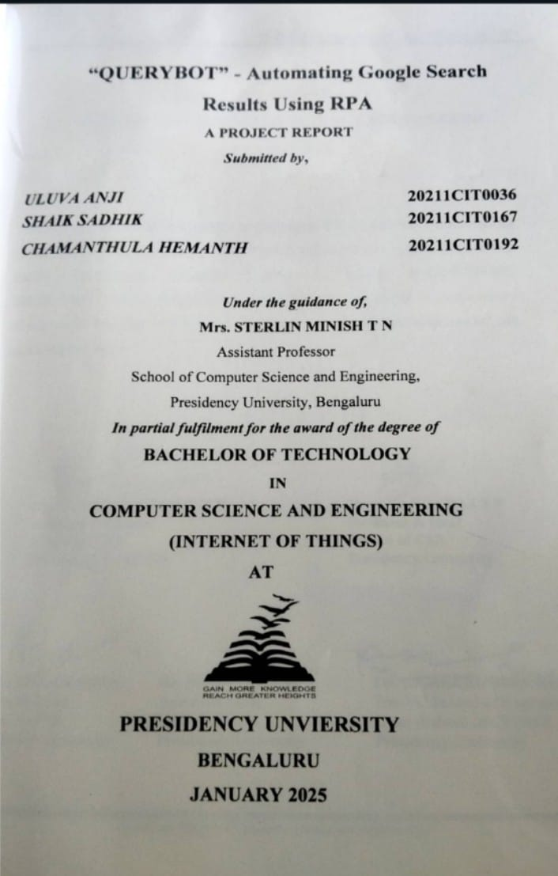

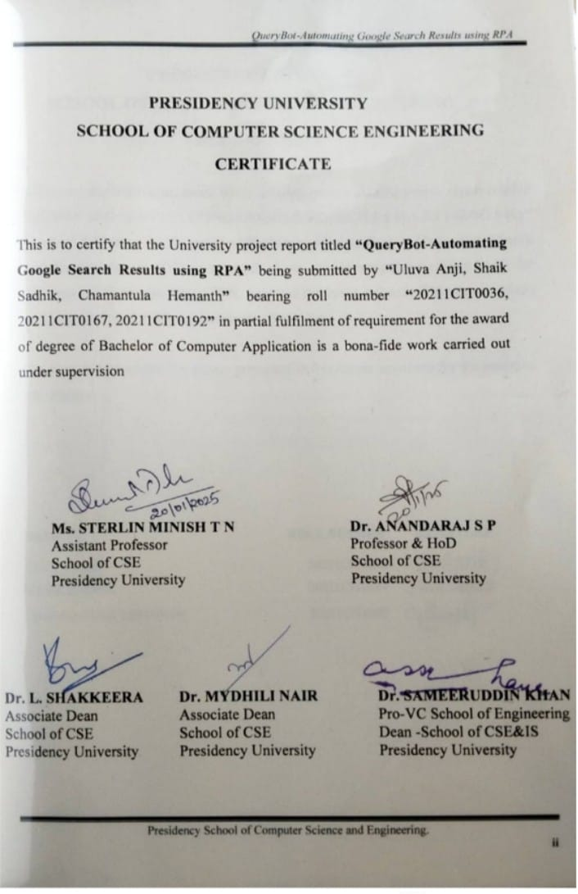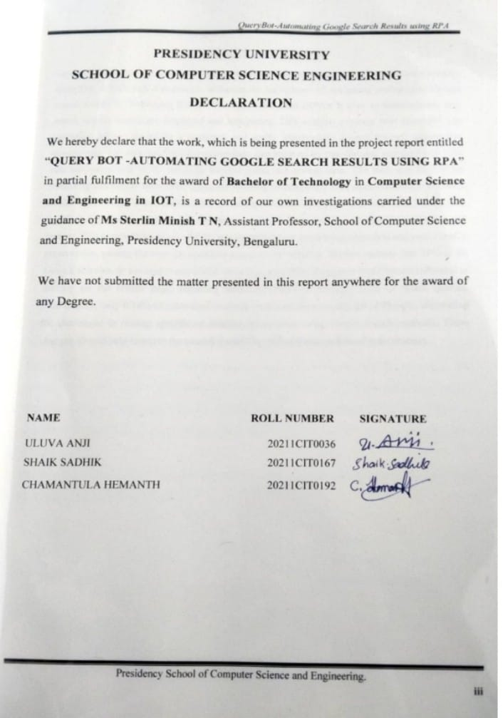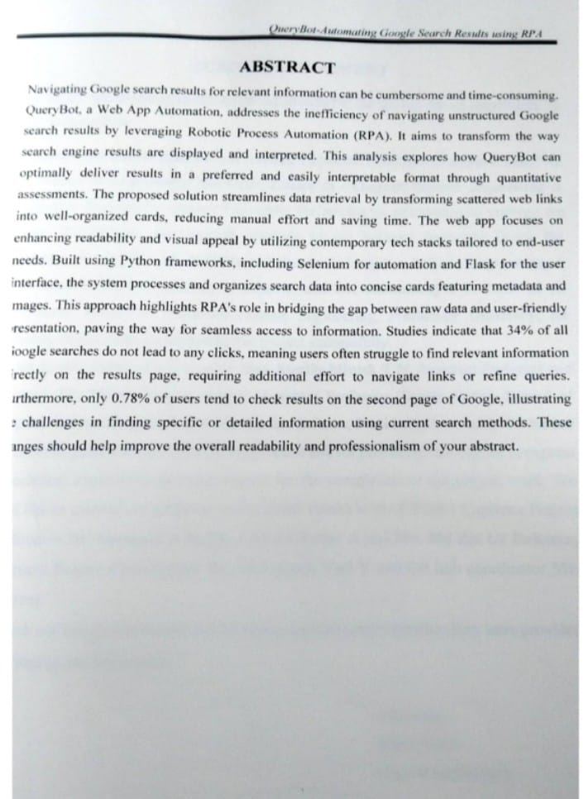

**TABLE OF CONTENTS**

`

|  |  |  |  |  |  |
| --- | --- | --- | --- | --- | --- |
| CHAPTER NO | TITLEABSTRACTACKNOWLEDGEMENTLIST OF FIGURES… | PAGE NUMBERivvx… |  |  |  |
| 1 | INTRODUCTION | 1-2 |  |  |  |
| 2 | LITERATURE REVIEW2.1 A Framework for Scientific and IndustrialUse Cases of RPA2.2 Exploring Academic Application of RPAfor Data Extraction2.3 Advanced RPA Techniques and User Interaction2.4 Advantages and Limitations of RPA in Organization2.5 User Friendly Data Analysis with RPA2.6 Integrating Machine Learning with RPA forUnstructured Data | 3-4 |  |  |  |
| 3 | RESEARCH GAPS OF EXSISTING METHODS3.1 Limited User-Centric Designs3.2 Absence of Real-Time User Engagement3.3 Scalability Issues with Dynamic Datasets3.4 Limited Integration of Advanced AI Techniques3.5 Limited Exploration of Hybrid Models(RPA andMachine Learning)3.7 Lack of Emphasis on Data Quality and Validation | 5-6 |  |  |  |
| 4 | PROOSED METHODS | 7-11 |  |  |  |
|  | 4.1 Technical Implementation4.1.1 User Registration and Authentication4.1.2 Search Query Input and Submission4.1.3 Search Automation and Data Extraction4.1.4 Data Processing and Structuring4.1.5 Results Presentation and User Interaction4.1.6 User Interface Enhancements |  |  |  |  |
|  | 4.2 UI Development |  |  |  |  |
| 5 | OBJECTIVES5.1 Develop a User-Friendly and Efficiently SearchAutomation Tool5.2 Automate the Process of Information Retrieval5.3 Present Search Results in a Structured and VisuallyAppealing Format5.4 Integrated Robotic Process Automation (RPA)5.5 Ensure a Robust and Secure User Experience5.6 Develop a User-Friendly Interface5.7 Explore the Integration of AI and NLP Techniques5.8 Continuously Evaluate and Improve the System | 12 |  |  |  |
| 6 | SYSTEM DESIGN & IMPLEMENTATION | 13-27 |  |  |  |
|  | 6.1 Tools Used6.1.1Backend Development with Flask-ALightweight and Flexible Framework6.1.2Data Extraction and Automation6.1.3 User Interface Development: The webDevelopment Trio-HTML, CSS andJAVA-SCRIPT6.1.4 Integration Frontend and Backend6.1.5 Data Storage and Management6.1.6 Security and Consideration6.1.7 AI Integration-GEMINILLM6.1.8 Implementation6.2 Benefits of Gemini LLM Integration6.3 Application Workflow for Query AutomationWith RPA6.3.1 Application Launch and Login Page6.3.2 Features of the Login Page6.3.3 Main Dashboard6.3.4 Search Automation Feature6.3.5 AI Chatbot Integration (Gemini)6.3.6 Chatbot Interaction (Gemini Integration)6.4 Workflow for Chatbot Integration6.4.1 User Input6.4.2 Sending the Query6.4.3 AI Response6.4.4 Continued Conversation6.4.5 Error Handling6.4.6 Logout Process6.5 Detailed Workflow Summary6.6 Technological Components6.61 Frontend6.6.2 Backend6.6.3 AI Integration6.6.4 Libraries and API’s |  |  |  |  |
| 7 | TIMELINE FOR EXCUTION OF PROJECT(GANTT CHART) | 28 |  |  |  |
| 8 | OUTCOMES8.1. Frontend Output8.2 Backend Codebase | 29-35 |  |  |  |
| 9 | FUTURE ENHANCEMENT andCOMMERCIALIZATION9.1 Future Enhancement9.1.1 Multi-Languages Support9.1.2 Voice Interaction Feature9.1.3 Advanced AI Integration for Personalization9.1.4 Integration with Third-Party Tools and API’s9.1.5 Mobile Application Development9.1.6 Data Analytics Dashboard9.1.7 Offline Query Support9.1.8 Security and Privacy Enhancement9.1.9 Gamification Features9.1.10 AI-Powered Recommendation9.1.11 Subscription-Based Model9.1.12 Freemium Licensing9.1.13 B2B Licensing9.1.14 API Monetization9.1.15 White-label Solution9.1.16 In-App Purchases9.1.17 Partnership Programs | 36-43 |  |  |  |
| 10 | RESULTS AND DISCUSSION10.1 Overcoming Limited User Base andExpandable Architecture10.2 Crossing Communication Barries and DataPrivacy issues10.3 Enhancing Query Management Efficiency10.4 Overcoming Implementation Costs10.5 Addressing Limitations in Existing Tools | 44-46 |  |  |  |
| 11 | CONCLUSION | 47 |  |  |  |
| 12 | REFERENECE | 48-49 |  |  |  |
| 13 | APPENDICES13.1 Import Required Libraries and Frameworks13.2 Initialize Flask Application13.3 User Authentication System13.4 User Login13.5 User Registration13.6 Logout Functionality13.7 Search Query Input13.8 Web Scraping via Selenium13.9 Extract Links and Metadata13.10 Generate HTML Output13.11 Initialize Gemini Chatbot13.12 Process AI Responses13.13 Session Handling | 50-57 |  |  |  |

### List of Figures

|  |  |  |  |  |
| --- | --- | --- | --- | --- |
| **Sl. No.** | **Figure Number** | **Figure Name** | **Page No.** | |
| 1 | 1.1 | Use Case Diagram of Query Bot | | 10 |
| 2 | 1.2 | Blueprint Framework of the Top | | 11 |
| 3 | 2.1 | Gantt Chart of Timeline | | 28 |
| 4 | 3.1 | Splash/Welcome Screen | | 29 |
| 5 | 3.2 | How it Works | | 29 |
| 6 | 3.3 | Registration Page | | 30 |
| 7 | 3.4 | Registration Filling | | 30 |
| 8 | 3.5 | Login Page | | 31 |
| 9 | 3.6 | Home Page | | 31 |
| 10 | 3.7 | GEMINI AI Chat Bot | | 32 |
| 11 | 3.8 | Output Screen | | 33 |
| 12 | 3.9 | Output Screen in Dark Mode | | 34 |
| 13 | 3.10 | Saving Output as Pdf | | 34 |
| 14  15  16  17  18 | 3.11  4.1  4.2  4.3  4.4 | Flask as Server-CodeBase  Flask Code as Backends  Falsk LoginPage  Flask WebPage  Results of the Output | | 35  53  53  54  54 |

# CHAPTER-1

# INTRODUCTION

In today's digital age, the way we access and consume information has drastically changed. The internet, particularly Google Search, has become an indispensable tool for finding information on almost any topic. However, navigating through countless search results can be time-consuming and inefficient. To address this challenge, we have developed a web application that automates the process of searching for information and presents it in a user-friendly format.

The evolution of Search Engine Optimization (SEO) mirrors this growing challenge. Early SEO practices relied heavily on simplistic keyword matching and rudimentary indexing. Subsequent advancements, including Natural Language Processing (NLP) and AI-powered algorithms, aimed to refine search accuracy. Despite these improvements, studies indicate a significant disconnect between search results and user needs. A substantial percentage of searches result in no clicks, demonstrating that users frequently struggle to find pertinent information directly on the Search Engine Results Page (SERP). Furthermore, user behavior studies reveal that only a minuscule fraction of users navigate beyond the first page of search results, leaving a vast amount of potentially valuable information unexplored. This highlights a critical gap: while search engines excel at indexing and ranking, they often fall short in presenting information in a readily consumable format.

RPA presents a promising solution to address these inefficiencies. By automating repetitive tasks and structuring disorganized data into user-friendly formats, RPA tools can significantly enhance the information retrieval process. Leveraging programming languages like Python and associated frameworks such as Selenium and BeautifulSoup, RPA solutions can automatically extract, analyze, and present information through tailored interfaces, minimizing manual effort. This research focuses on QueryBot, a system designed to demonstrate the practical application of RPA in optimizing data retrieval from search engines. QueryBot integrates automation with user-centered design principles, presenting search results in a visually appealing and easily digestible card-based layout, thereby streamlining access to key insights.

This research investigates QueryBot's capabilities in transforming unstructured search engine data into structured, readily usable formats. The study emphasizes the system's potential to automate

Link extraction, categorize metadata, and present results within a unified and intuitive framework. QueryBot's core functionality lies in its ability to collate data into concise cards. Each card contains essential information, including the link, a brief description (metadata), and relevant images, significantly reducing the cognitive load and time investment required by users. By effectively bridging the gap between raw search results and user-friendly output, QueryBot establishes itself as a practical and scalable solution applicable to a diverse range of domains, from academic research and market analysis to business intelligence and competitive analysis.

The broader implications of QueryBot extend beyond individual user convenience, offering potential applications in data-driven decision-making and knowledge management across various industries. By enabling efficient access to well-organized and relevant information, QueryBot can support organizations in identifying trends, conducting comprehensive analyses, and fostering innovation. Moreover, its scalable architecture allows adaptation to different use cases, from enhancing customer experience in e-commerce to facilitating evidence-based policy formulation in public administration. This versatility underscores the transformative potential of RPA-driven solutions like QueryBot in addressing information overload, optimizing workflows, and contributing to a more informed and productive digital society.

Moreover, QueryBot's modular and extensible design makes it highly adaptable for integration with emerging technologies such as machine learning and artificial intelligence. Future iterations could incorporate predictive analytics to anticipate user needs or provide personalized insights tailored to specific preferences or contexts. These advancements would not only enhance user satisfaction but also position QueryBot as a cutting-edge tool in the evolving landscape of information retrieval and automation, offering long-term value to diverse stakeholders.

# CHAPTER-2

# LITERATURE REVIEW

This section explores into the existing literature on Robotic Process Automation (RPA) in search result automation and data structuring. We explore past studies and methodologies aimed at addressing inefficiencies in handling unstructured data, encompassing both academic and industry-specific applications. The review highlights key findings and identifies research gaps, particularly with regards to user-centric design and limitations in current approaches.

* 1. **González Enríquez et.al (2023) A Framework for Scientific and Industrial Use Cases of RPA:**

This research by González Enríquez et al. meticulously maps the scientific and industrial applications of RPA, with a particular focus on its effectiveness in streamlining repetitive workflows. The authors highlight substantial successes achieved through RPA implementation in industries like finance and healthcare. However, they also identify a crucial gap – the limited application of RPA for tasks involving unstructured data, such as search engine results. Their findings suggest that while RPA significantly reduces manual effort and increases efficiency, user-centric implementations remain underdeveloped. Existing solutions primarily focus on automating backend processes without delving into the design of user-friendly front-end interfaces. The study further emphasizes the need for tighter integration of RPA with contemporary technologies like AI and machine learning to enhance its utility in real-time user-facing scenarios.

**2.2 Gupta Ankur, Prabhat (2022) Exploring Academic Applications of RPA for Data Extraction:**

Gupta et al. explore the potential of RPA in academic settings by focusing on bots designed for tasks like Google Scholar data extraction and alumni tracking. Their study demonstrates the significant potential of RPA in automating complex, data-intensive processes. However, these implementations primarily cater to institutional efficiencies by focusing on areas such as research analytics and faculty screening. The user interaction aspect remains underdeveloped. The authors identify key challenges in deploying RPA within dynamic data environments where real-time user engagement is crucial.

**2.3 Jyothi & Shankar (2024) Advanced RPA Techniques and User Interaction:**

Jyothi and Shankar delve into advanced RPA techniques, emphasizing the role of tools like Selenium in web-based automation. They underscore the need for RPA systems to adapt to modern web interfaces. However, they acknowledge a critical gap – the lack of focus on interactive user outputs within current solutions. Their findings highlight that while backend automation has matured

considerably, front-end user applications haven't kept pace. This indicates a need for further development in user-friendly interfaces to enhance the user experience.

**2.4 Plattfaut & Borghoff (2024) Advantages and Limitations of RPA in Organizations:**

Plattfaut and Borghoff examine the advantages and limitations of RPA, particularly within organizational settings. They acknowledge the effectiveness of RPA in reducing manual workloads. However, they highlight that current implementations often overlook quantifiable user benefits such as ease of navigation and engagement. They propose a research agenda calling for studies that investigate how RPA can better address end-user needs, specifically within complex data environments.

**2.5 Mishra.A, Mishra.S and Kumarn N S (2022) User-Friendly Data Analysis with RPA** :

The study by A. Mishra, S. Mishra, and N. S. Kumar titled "Data Analysis Using Robotic Process Automation Study on Web Scraping Using UiPath Studio" provides an indepth exploration of leveraging UiPath Studio for automated web data extraction, particularly in web scraping applications. The authors detail a framework for extracting structured data from unstructured web content, such as job postings on LinkedIn. The study demonstrates how RPA bots can navigate web platforms, extract relevant data, and store it in structured formats for further analysis (CSV or Excel). A notable aspect of this paper is its focus on user-friendly implementation through UiPath's low-code tools, thus enabling automation even for non-technical users. However, the authors also identify limitations in scaling such solutions for large-scale and dynamic data sources.

**2.6 Poznan Researchers (2023) Integrating Machine Learning with RPA for Unstructured Data:**

This study by researchers from Poznan delves into the potential of integrating machine learning with RPA to enhance processing of unstructured data. The authors propose a hybrid model that leverages machine learning techniques like deep learning and conditional random fields for information extraction from text-based datasets. The paper also acknowledges challenges in scaling RPA solutions to handle diverse unstructured inputs while maintaining accuracy and efficiency. While the research proposes an innovative approach, it doesn't address end-user applications or usability aspects, which remain critical for widespread adoption.

# CHAPTER-3

# RESEARCH GAPS OF EXISTING METHODS

Based on the literature review, several key drawbacks and research gaps in existing RPA methods for information retrieval and data structuring have been identified. These gaps highlight areas where further research and development are needed to create more effective and user-friendly solutions.

**3.1 Limited User-Centric Designs:**

* + Existing RPA systems often prioritize backend automation and process efficiency, neglecting the design of intuitive and user-friendly front-end interfaces. This leads to systems that are powerful but difficult for non-technical users to interact with effectively.
  + The focus on backend processes results in a lack of visual appeal and interactive elements, hindering user engagement and making it challenging for users to quickly understand and utilize the extracted data.

* 1. **Absence of Real-Time User Engagement:**
  + Current RPA implementations primarily focus on static data extraction and processing, lacking the ability to provide real-time data structuring or interactive updates as information changes. This limits their applicability in dynamic environments where data is constantly evolving.
  + The absence of real-time interaction prevents users from actively participating in the data extraction and structuring process, reducing their control and potentially leading to less relevant or outdated results.

**3.3 Scalability Issues with Dynamic Datasets:**

* + Many RPA solutions struggle to handle large-scale and dynamic datasets, particularly in scenarios where the data source's structure or content changes frequently. This limits their applicability in real-world scenarios involving vast amounts of constantly updating information.
  + Adapting RPA bots to changes in website layouts or data formats requires significant maintenance and reprogramming, making these solutions less robust and more costly to maintain in the long run.

**3.4 Limited Integration of Advanced AI Techniques:**

* + Current RPA implementations often lack integration with advanced AI techniques like Natural Language Processing (NLP) and machine learning. This limits their ability to understand the context and meaning of unstructured data, leading to less accurate or less relevant results.
  + The absence of AI integration also hinders the ability of RPA systems to perform more complex tasks like sentiment analysis, topic extraction, or predictive analytics, which could significantly enhance the value of the extracted information.

* 1. **Focus on Institutional Efficiencies Over Individual User Needs:**
  + A significant portion of existing research and implementations focuses on organizational benefits such as research analytics, workflow optimization, or internal process automation, neglecting the needs and usability for individual users.
  + This institutional focus often results in systems that are designed for specific tasks within an organization but lack the flexibility and adaptability to be used by a wider range of users with diverse needs and skill levels.

**3.6 Limited Exploration of Hybrid Models (RPA and Machine Learning):**

* + There is limited research and development on hybrid models that combine RPA with machine learning techniques to create more powerful and intelligent automation solutions.
  + Integrating machine learning could enable RPA systems to handle more complex tasks, such as predictive modeling, anomaly detection, and personalized information retrieval, but this area remains relatively unexplored.

**3.7 Lack of Emphasis on Data Quality and Validation:**

* + While RPA effectively extracts data, there is often a lack of emphasis on ensuring the quality, accuracy, and validity of the extracted information. This can lead to the dissemination of inaccurate or incomplete data, which can have serious consequences.
  + Existing methods often lack robust validation mechanisms to verify the accuracy of the extracted data and identify potential errors or inconsistencies, making it difficult to trust the reliability of the results.

# CHAPTER-4

# PROPOSED METHODOLOGY

QueryBot is a web application designed to revolutionize the way users interact with search engines. It addresses the inherent inefficiencies of traditional search experiences, where users often spend considerable time sifting through numerous links and manually extracting relevant information. By leveraging the power of Robotic Process Automation (RPA) and integrating user-centric design principles, QueryBot automates the process of information retrieval, transforming raw search results into a structured, easily digestible format.

* 1. **Workflow Breakdown:**

**4.1.1 User Registration and Authentication:**

The workflow begins with the user registration process. New users can create an account by providing their email address and choosing a strong password. This step serves multiple purposes. Firstly, it ensures user authentication, preventing unauthorized access and enhancing the security of user data. Secondly, it enables the system to personalize the user experience in the future, potentially offering customized search suggestions or saving user preferences.

Once registered, users can log in to the application using their registered email and password. The system maintains user sessions, allowing for seamless navigation and access to their account features without the need for repeated logins. This enhances user convenience and streamlines the overall user experience.

**4.1.2 Search Query Input and Submission:**

Upon successful login, users are presented with the main interface of the application. A prominent search bar is prominently displayed at the forefront of the interface. This serves as the primary point of interaction for users to enter their search queries. The search bar is designed to be intuitive and user-friendly, encouraging users to easily input their search terms.

The system is designed to accept a wide range of search queries, from simple keywords to complex phrases and Boolean operators. Once the user enters their query and clicks the "Search" button, the system initiates the search automation process.

**4.1.3 Search Automation and Data Extraction:**

This stage leverages the power of RPA to automate the search process and extract relevant information from the web. The system utilizes the Selenium library, a powerful tool for controlling

web browsers programmatically. Selenium allows the system to open a new browser instance, navigate to the specified search engine (e.g., Google), and simulate user interactions such as entering the search query and submitting the form.

Once the search engine returns the results page, the system employs the BeautifulSoup library, a robust Python library for parsing HTML and XML documents. BeautifulSoup effectively extracts the relevant information from each search result, including:

* **Link:** The URL of the search result webpage.
* **Title:** The title of the webpage as displayed in the search results.
* **Description:** The search result snippet or meta description, providing a brief overview of the webpage's content.
* **Image URL (optional):** If an image is associated with the search result, the system extracts the URL of the image for visual representation.

**4.1.4 Data Processing and Structuring:**

The raw data extracted from the search engine results page is then processed and structured into a format that is easily understandable and navigable for the user. QueryBot presents the search results in a visually appealing and intuitive card-based layout. Each card represents an individual search result and contains the following elements:

* **Title:** The title of the webpage, displayed prominently to provide a quick overview of the content.
* **Description:** A concise description or snippet from the webpage, offering a brief summary of the content.
* **Image (optional):** If an image URL was extracted, the system displays the image within the card, providing a visual context for the search result.
* **Link:** The URL of the webpage is presented as a clickable hyperlink, allowing users to easily access the full content with a single click.

This card-based layout enhances the visual appeal and readability of the search results, making it easier for users to quickly scan and identify relevant information.

**4.1.5 Result Presentation and User Interaction:**

The processed and structured search results are then presented to the user within the application interface. The system dynamically renders the card-based layout, displaying all the extracted information in a clear and concise manner.

To further enhance user interaction and navigation, the system provides several intuitive controls:

* **Navigation Controls:** Users can easily navigate through the search results using "next" and "previous" buttons or by utilizing pagination controls. This allows users to explore the results efficiently and access information beyond the initial page of results.
* **Search Refinement (Optional):** Future iterations of QueryBot could incorporate advanced filtering and sorting options. This would allow users to refine their search results based on specific criteria, such as date of publication, language, source domain, or relevance score.

**4.1.6 User Interface Enhancements:**

QueryBot prioritizes user experience by incorporating several features to enhance the overall usability and appeal of the application:

* **Dark Mode/Light Mode Toggle:** This feature allows users to switch between dark and light mode according to their preferences. Dark mode can reduce eye strain and improve readability in low-light conditions, while light mode provides a more traditional and familiar interface.
* **Print Option:** Users can easily print the current search results for offline reference or further analysis. This feature is particularly useful for academic research, note-taking, or presentations.

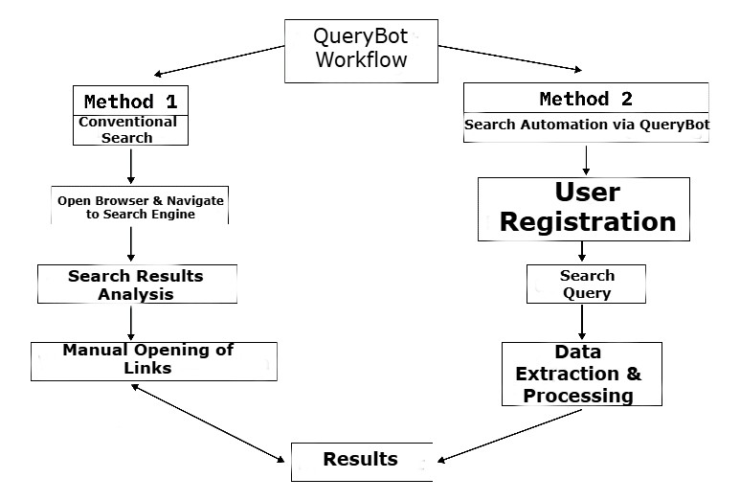

Fig 1.1 Workflow of QueryBot

**4.2 Technical Implementation:**

**Backend Development:**

* + **Flask:** The Flask framework is utilized as the foundation for the web application. Flask provides a lightweight and flexible environment for developing web applications, handling user requests, and managing server side logic.
  + **API Endpoints:** Flask is used to create API endpoints for various functionalities, including search query submission, data extraction, result rendering, and user authentication.
  + **Session Management:** Flask sessions are employed to store user authentication information, such as login status and user ID. This allows the system to maintain user sessions and provide a seamless user experience. o **Database (Optional):** Depending on the specific requirements, a database can be integrated to store user data, preferences, and search history. This can enable personalized features and improve user experience over time.

**4.2 UI Development:**

* **HTML, CSS, and JavaScript:** These core web technologies are used to create the user interface (UI) of the application. HTML provides the structural framework, CSS defines
  + - the visual style and layout, and JavaScript

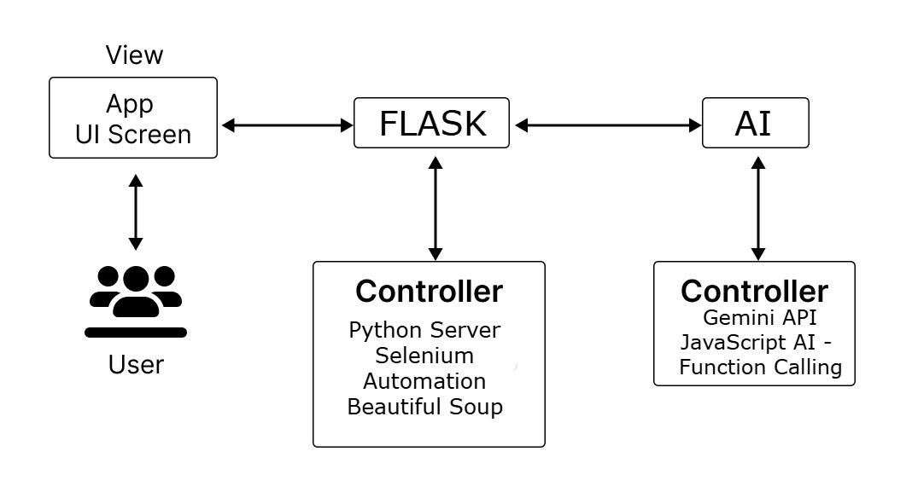

Fig.1.2 – Blueprint framework of the app.

# CHAPTER-5

# OBJECTIVES

These objectives encapsulate the key goals and functionalities of the QueryBot project:

**5.1 Develop a user-friendly and efficient search automation tool** that empowers users to extract relevant information from search results with minimal effort.

**5.2 Automate the process of information retrieval** from search engines, eliminating the need for manual navigation and data extraction.

**5.3 Present search results in a structured and visually appealing format**, such as a card-based layout, for easy consumption and analysis.

**5.4 Integrate Robotic Process Automation (RPA) techniques** using libraries like Selenium and Beautiful Soup to effectively interact with web browsers and extract data from web pages.

**5.5 Ensure a robust and secure user experience**, including secure user authentication and data privacy measures.

**5.6 Develop a user-friendly interface** with intuitive navigation controls, a responsive design, and customizable options such as dark mode and print functionality.

**5.7 Explore the integration of AI and NLP techniques** to enhance search accuracy, provide personalized results, and enable more sophisticated data analysis.

**5.8 Continuously evaluate and improve the system** based on user feedback and advancements in RPA, AI, and web technologies.

# CHAPTER-6

# SYSTEM DESIGN & IMPLEMENTATION

This chapter explores the technical foundation of QueryBot, outlining the tools, technologies, and methodologies employed in its development. We will examine each component in detail, highlighting the rationale behind the chosen technologies and how they contribute to the overall functionality and performance of the application.

**6.1 Tools Used**

**6.1.1 Backend Development: Flask - A Lightweight and Flexible Framework**

At the core of QueryBot lies Flask, a lightweight and versatile Python framework for web application development. Flask was chosen as the backend framework due to its several key advantages:

* **Minimalistic Core:** Flask provides a streamlined and unopinionated foundation for web applications. It offers a small core with minimal dependencies, allowing developers to build applications with a high degree of flexibility and control. This minimalism is particularly beneficial for smaller-scale projects like QueryBot, where a full-fledged framework like Django might introduce unnecessary complexity and overhead.
* **Extensibility:** Despite its minimalistic nature, Flask is highly extensible. It provides a robust plugin system that allows developers to easily integrate additional functionalities through third-party libraries and extensions. This flexibility is crucial for adapting QueryBot to evolving requirements and integrating new features in the future.
* **Large and Active Community:** Flask boasts a large and active community of developers. This provides access to a wealth of resources, including extensive documentation, tutorials, and readily available solutions for common challenges. The active community also ensures ongoing development and support for the framework, ensuring its continued relevance and robustness.
* **Focus on WSGI:** Flask adheres to the WSGI (Web Server Gateway Interface) standard, which promotes interoperability between web servers and Python web applications. This makes it easier

to deploy QueryBot on different web servers and integrate it with other components of the web infrastructure.

**6.1.1.1 Why Flask over Django?**

While Django is another popular Python web framework, it was not chosen for QueryBot due to its inherent differences:

**6.1.1.2 Django's Scope:** Django is a full-featured framework designed for large-scale applications

with complex requirements. It comes with built-in features such as an Object-Relational Mapper (ORM), an admin interface, and a robust authentication system. These features, while powerful, can introduce unnecessary overhead for smaller projects like QueryBot.

* **Flexibility:** Django's emphasis on convention over configuration can sometimes limit flexibility and customization. QueryBot requires a high degree of flexibility to adapt to different search engines, integrate new features, and accommodate evolving user requirements. Flask, with its less opinionated approach, provides greater control over the application's structure and behavior.
* **Learning Curve:** Django has a steeper learning curve due to its comprehensive feature set. Flask, with its minimalistic nature, is easier to learn and use, allowing for faster development and prototyping.

**6.1.2 Data Extraction and Automation: The RPA Powerhouse - Selenium and BeautifulSoup**

At the heart of QueryBot's functionality lies the ability to automate the process of extracting relevant information from search engine results pages. This critical task is accomplished through the combined power of two powerful libraries:

* **Selenium:** Selenium is a powerful and versatile library for automating web browsers. It allows QueryBot to simulate user interactions with web browsers programmatically. This includes:
  + **Opening a new browser instance:** Selenium creates a new browser window, enabling QueryBot to interact with the search engine independently of the user's browser.
  + **Navigating to the search engine:** Selenium instructs the browser to navigate to the specified search engine's URL.
  + **Submitting the search query:** Selenium simulates user input by entering the search query into the search bar and submitting the form.
  + **Interacting with web elements:** Selenium provides methods for interacting with various web elements, such as clicking on links, filling out forms, and scrolling through the page.
  + **BeautifulSoup:** Once Selenium has retrieved the search results page, BeautifulSoup takes over. This Python library excels at parsing HTML and XML documents, enabling QueryBot to extract the relevant information from the webpage's structure. BeautifulSoup provides a flexible and intuitive API for navigating the HTML tree, locating specific elements, and extracting their content.

**6.1.2.1 Why Selenium and BeautifulSoup?**

Several other libraries and tools exist for browser automation and web scraping. However, Selenium and BeautifulSoup offer a compelling combination of features that make them ideal for QueryBot's requirements:

* + **Cross-Platform Compatibility:** Both libraries are compatible with a wide range of operating systems and browsers, ensuring that QueryBot can function reliably across different user environments.
  + **Robustness and Flexibility:** Selenium and BeautifulSoup provide a robust and flexible foundation for web automation. They can handle complex web pages with dynamic content and adapt to changes in website layouts.
  + **Community Support:** Both libraries have large and active communities, providing access to extensive documentation, tutorials, and readily available solutions for common challenges.

**6.1.3 User Interface Development: The Web Development Trio - HTML, CSS, and JavaScript**

The user interface (UI) plays a crucial role in determining the overall user experience. QueryBot's

UI is built upon the foundation of three core web technologies:

* + **HTML:** HTML (Hyper Text Markup Language) provides the structural foundation for the user interface. It defines the arrangement and hierarchy of elements on the page, such as the search bar, search result cards, navigation controls, and other UI components.
  + **CSS:** Cascading Style Sheets (CSS) governs the visual presentation of the UI elements. CSS allows us to define the styles and appearance of elements, including colors, fonts,

spacing, and layout. This enables us to create a visually appealing and user-friendly interface that is both aesthetically pleasing and easy to navigate.

* **JavaScript:** JavaScript adds interactivity and dynamic behavior to the UI. It allows for:
  + **Event Handling:** Responding to user interactions, such as clicks, mouse movements, and keyboard input.
  + **Dynamic Content Updates:** Updating the UI in real-time, for example, displaying search results as they are being fetched or providing feedback to the user.
  + **User Interface Enhancements:** Implementing features like dark mode/light mode toggles, smooth animations, and interactive elements to enhance the overall user experience.

**6.1.3.1 Why Not Use a JavaScript Framework (e.g., React, Vue.js)?**

While JavaScript frameworks like React and Vue.js offer powerful features for building complex and interactive web applications, they are not strictly necessary for QueryBot's specific requirements. QueryBot primarily focuses on displaying static content (search results) and providing basic user interactions. The overhead of using a full-fledged framework for this purpose might be unnecessary and could potentially increase development time and complexity.

* + 1. **Integrating Backend and Frontend in Flask**

QueryBot is powered by Flask, a streamlined and adaptable Python framework perfect for building web applications. With its simple and lightweight structure, Flask promotes an organized and maintainable codebase, making it an excellent choice for smaller-scale projects like QueryBot. In contrast to more complex frameworks, Flask keeps things straightforward, eliminating excess features and reducing development overhead, which accelerates the overall process.

To integrate the frontend (HTML, CSS, and JavaScript) with Flask, developers can serve static files like CSS stylesheets and JavaScript files directly from the Flask server using the static folder. HTML templates are rendered through Jinja2, Flask's built-in templating engine, which allows dynamic content to be inserted into static HTML pages. This setup ensures smooth interaction between the backend and frontend, enabling Flask to handle user requests while the frontend provides an interactive, user-friendly experience. This flexibility ensures that QueryBot can evolve and seamlessly integrate new technologies

and features as needed.

**6.1.5 Data Storage and Management (Optional):**

Depending on the specific requirements and future enhancements, QueryBot may require mechanisms for storing user data, preferences, and search history. Several options can be considered for data storage:

* **Cookies:** Cookies can be used to store user preferences, such as dark mode settings, and to maintain session information.
* **Local Storage:** The browser's local storage can be used to store user data locally, such as search history.
* **Database:** If more complex data storage and retrieval are required in the near future or enhancement, a database can be integrated such as:
  + **SQLite:** A lightweight and embedded database that can be easily integrated into the Flask application.
  + **PostgreSQL/MySQL:** More robust and scalable relational databases for
    - handling larger datasets and complex data relationships.

The choice of data storage mechanism will depend on the specific requirements of the application and the anticipated data volume.

**6.1.6 Security Considerations:**

Security is paramount for any web application. QueryBot incorporates several measures to ensure user data security and prevent vulnerabilities:

* **Secure Authentication:** User authentication is implemented using secure hashing algorithms to protect user passwords.
* **Input Validation and Sanitization:** User input is carefully validated and sanitized to prevent security vulnerabilities like SQL injection and cross-site scripting (XSS).
* **HTTPS:** The application is deployed over HTTPS to encrypt communication between the client and the server, protecting user data from interception.

**6.1.7 AI Integration: Gemini LLM - Enhancing User Interaction**

A significant enhancement to QueryBot is the integration of the Gemini LLM, a powerful large language model developed by Google AI Team. This integration introduces chatbot functionality, enabling users to interact with the system through natural language conversation.

**Why Gemini LLM?**

The Gemini LLM was chosen due to its:

* **Advanced Capabilities:** Gemini is a state-of-the-art LLM with exceptional capabilities in understanding and generating human language. It excels in tasks like text generation, translation, summarization, and code generation, making it well suited for a chatbot application.
* **Versatility:** Gemini can handle a wide range of conversational tasks, from answering simple questions to engaging in more complex discussions and providing informative summaries.
* **Ease of Integration:** Google provides a user-friendly API for interacting with the Gemini LLM, making it relatively straightforward to integrate into the QueryBot application.

**6.1.8 Implementation:**

**6.1.8.1 API Integration:** The QueryBot application utilizes the Google Generative AI API to interact with the Gemini LLM. This API provides a convenient way to send messages to the model and receive responses.

**6.1.8.2 Chatbot Interface:** A dedicated chatbot interface is implemented within the QueryBot application. This interface typically includes:

* + **Input Field:** A text input field where users can type their messages.
  + **Send Button:** A button to submit the user's message to the chatbot.
  + **Chat History:** A display area to show the conversation history, including both user messages and responses from the Gemini LLM.

**6.1.8.3 Message Handling:**

* + When the user submits a message, the application sends the message to the Gemini LLM using the Google Generative AI API.
  + The Gemini LLM processes the message and generates a response.
  + The application receives the response from the LLM and displays it in the chat history, along with the user's original message.

**6.1.8.4 User Interface Enhancements:**

* + The chat interface is designed to be visually appealing and user-friendly.
  + Clear visual cues are used to distinguish between user messages and responses from the LLM.
  + The interface may include additional features such as the ability to clear the chat history or to switch between different conversation modes.

**6.2 Benefits of Gemini LLM Integration:**

* **Enhanced User Experience:** The chatbot interface provides a more intuitive and engaging way for users to interact with QueryBot. Users can simply ask questions or provide instructions in natural language, eliminating the need to navigate through complex search results.
* **Improved Information Retrieval:** The Gemini LLM can be used to refine search queries, identify relevant keywords, and even summarize search results, providing users with more concise and informative information.
* **Personalized Assistance:** The LLM can be used to provide personalized assistance to users, such as answering questions about the application's features, offering suggestions for search queries, and providing customized search results based on user preferences.
* **Expanded Functionality:** The integration of the Gemini LLM opens up new possibilities for QueryBot, such as:
  + **Natural Language Search:** Allowing users to search using natural language queries instead of keywords.
  + **Question Answering:** Enabling users to ask questions about the search results and receive concise answers.
  + **Summarization:** Providing summaries of long articles or web pages.
  + **Translation:** Translating search results or providing real-time translation during conversations.

The integration of the Gemini LLM significantly enhances the capabilities of QueryBot, transforming it from a simple search result aggregator into a more intelligent and interactive assistant. By leveraging the power of this advanced AI model, QueryBot can provide a more personalized, informative,

and engaging user experience, ultimately revolutionizing the way users interact with search engines and access information online.

# 6.3 Application Workflow for Query Automation with RPA

This workflow will describe the process from when a user enters the app to when they log out, including all key functionalities such as search automation and interaction with the AI chatbot powered by the Gemini integration.

**6.3.1 Application Launch and Login Page**

When the user opens the application, the first screen they encounter is the **login page**.

**6.3.2 Features of the Login Page:**

* + **URL:** The app runs at 127.0.0.1:5000/#login or a similar route on localhost.
  + **UI Design:**
    - A clean and responsive UI with a vibrant gradient background for aesthetic appeal. o "Welcome to Query Automation with RPA" is displayed as a heading, introducing the app's purpose.
    - Below the header, users see a prompt: *"Discover the Top 10 Links with a Simple Search"*.
  + **Input Field:**
    - Users must enter their credentials (e.g., email/username and password) to access the app.
    - If credentials are invalid, a message will appear prompting the user to retry.
  + **Login Button:**
    - A button labeled **"Login"** allows users to submit their credentials.
    - Upon successful login, the user is redirected to the **main dashboard**.

**6.3.3 Main Dashboard**

Once the user logs in successfully, they are taken to the **main dashboard**. The dashboard is the central hub

where users interact with the app's primary features.

**Key Components of the Main Dashboard (as shown in the provided image):**

1. **Header Section:**

* + - The header prominently displays the title: *"Welcome to Query Automation with RPA"*.
    - A subheading below introduces the app's functionality: *"Discover the Top 10 Links with a Simple Search"*.

**6.3.4** **Search Automation Feature:**

* + - Users see a white card centered on the page with:
      * **Input Field:** A text field labeled *"Enter search key"* where users can input keywords.
      * **Search Button:** A green button labeled **"Search"** initiates the automated search for the top 10 links.
    - **Functionality:**
      * When the user clicks the **Search** button, the app performs a search using the provided keyword.
      * The results are displayed in a clean, organized list format.
      * Each link is clickable, allowing users to open it in a new tab.
      * The process ensures quick and efficient delivery of search results.

**6.3.5 AI Chatbot Integration (Gemini):**

* + - Below the search functionality, users can see the **"Chat with AI Bot"** button.
    - **Button Design:**

▪ A red button labeled **"Chat with AI Bot"** stands out clearly.

o **Functionality:**

* When the user clicks the button, they are redirected to the chatbot interface integrated with Gemini AI.

**6.3.6 Chatbot Interaction (Gemini Integration)**

The chatbot interface provides an interactive platform for users to communicate with the AIpowered assistant.

**UI Design of the Chatbot:**

* + **Header Section:**
    - A green header bar with the title: *"QueryBot Chatbot"*, along with the subtitle *"Your AI assistant"*.
  + **Message Display Area:**
    - The central portion of the screen is the **chat window**, which dynamically displays chat messages.
    - Messages are differentiated as follows:
      * **User Messages:** Displayed on the right side with a green background.
      * **AI Responses:** Displayed on the left side with a white background and light gray border.
  + **Input Section:**
    - A text box at the bottom allows the user to type their queries.
    - A blue **"Send"** button is located next to the text box to submit queries.

**6.4 Workflow for Chatbot Interaction:**

**6.4.1** **User Input:**

* + - The user types a question or request in the input field (e.g., "What are the top 10 links for Python tutorials?").

**6.4.2 Sending the Query:**

* + - When the **Send** button is clicked, the user's message is added to the chat window.
    - The message is sent to the **Gemini AI model** for processing.

**6.4.3** **AI Response:**

* + - The Gemini model generates a detailed response and sends it back to the chat. o The response is displayed in the chat window with proper formatting.
* Markdown support allows rich text formatting, ensuring responses are easy to read.

**6.4.4 Continued Conversation:**

o Users can continue asking follow-up questions or inputting new queries, and the chatbot will respond accordingly.

**6.4.5 Error Handling:**

o If the chatbot encounters any issues (e.g., connectivity errors or invalid input), an error message will be displayed to notify the user.

**6.4.6 Logout Process**

After the user has completed their tasks—whether performing searches or interacting with the chatbot—they can **log out** of the application.

**Logout Button:**

* + A red **"Logout"** button is located at the top-right corner of the main dashboard.
  + **Functionality:**
    - When the user clicks the Logout button:
      1. The session is terminated.
      2. The user is redirected back to the **login page**.

• **User Experience:**

* + - A confirmation message may appear, such as *"You have been successfully logged out"*.

**6.5 Detailed Workflow Summary**

Here is a step-by-step flow of the user experience:

**Step 1: Launch the Application**

o The user opens the app in their browser (e.g., 127.0.0.1:5000).

* + - They land on the **login page**.

**Step 2: Login**

* + - The user inputs their credentials (e.g., username/email and password) and clicks the **Login** button.
    - If credentials are valid, the user is taken to the **main dashboard**.
    - If invalid, an error prompt is displayed.

**Step 3: Explore the Main Dashboard**

* + - The user is welcomed with the title *"Welcome to Query Automation with RPA"*. o They see the search automation functionality and the chatbot integration option.

**Step 4: Perform a Search**

* + - In the input field labeled *"Enter search key"*, the user types a keyword (e.g., "Python tutorials").
    - Clicking the **Search** button retrieves the top 10 links related to the search query.
    - The results are displayed in an organized format, allowing the user to explore each link.

**Step 5: Interact with the AI Chatbot**

* + - The user clicks on the **"Chat with AI Bot"** button to access the chatbot interface.
    - On the chatbot screen:
      * The user types a query into the input field and sends it.
      * The chatbot processes the query using the **Gemini AI model**.
      * Responses are displayed dynamically in the chat window.
* Users can continue interacting with the chatbot for further assistance.

**Step 6: Logout**

* + - Once the user has completed their tasks, they click the **Logout** button located in the top-right corner.
    - The user is redirected to the **login page**, and their session ends securely.

**6.6 Technological Components**

The project integrates various technologies to ensure smooth functioning:

**6.6.1 Frontend:**

* + **HTML, CSS, and Tailwind CSS:** Used for creating a clean, responsive UI.
  + **JavaScript:** Handles user interactions, chatbot functionality, and dynamic updates.
  + **Markdown Support:** Enabled through the **Showdown.js** library for rich text formatting.

**6.6.2 Backend:**

* + The backend handles:
    - User authentication.
    - Search automation logic for retrieving the top 10 links.
    - Gemini AI model integration for chatbot responses.

**6.6.3 AI Integration:**

* + The Gemini AI model (using the Google Generative AI API) powers the chatbot.
  + The AI processes user input and generates intelligent, human-like responses.

**6.6.4 Libraries and APIs:**

* + **TailwindCSS** for styling. o **Tailwind CDN** for Markdown rendering.
  + **Google Generative AI API** for chatbot interaction.

The **Query Automation with RPA** project provides a seamless user experience, combining search automation with advanced AI chatbot capabilities. The workflow ensures that users can:

* Quickly find the top 10 relevant links for their queries.
* Interact with a sophisticated AI chatbot for additional assistance.
* Safely log in and log out with secure session management.

By combining UI design, advanced Gemini AI integration, and backend support, the project offers an efficient solution for query automation and AI-driven interactions.

# CHAPTER-7

# TIMELINE FOR EXECUTION OF PROJECT (GANTT CHART)

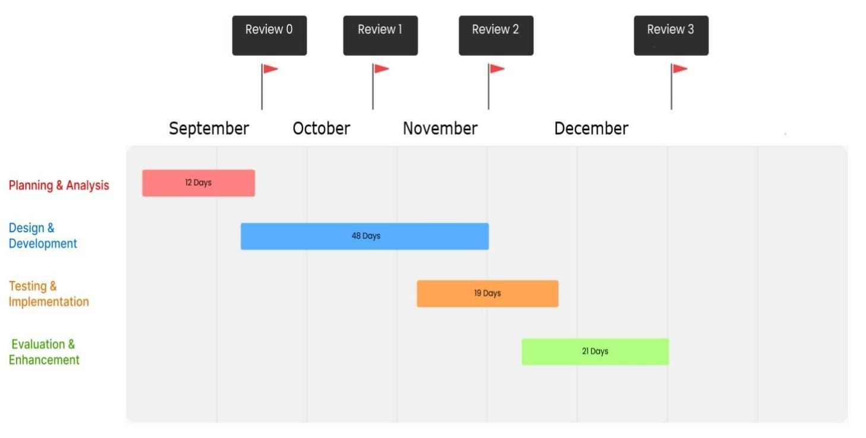

Fig.2.1 – Gantt Chart for Timeline

# CHAPTER-8

# OUTCOMES

## Frontend Output

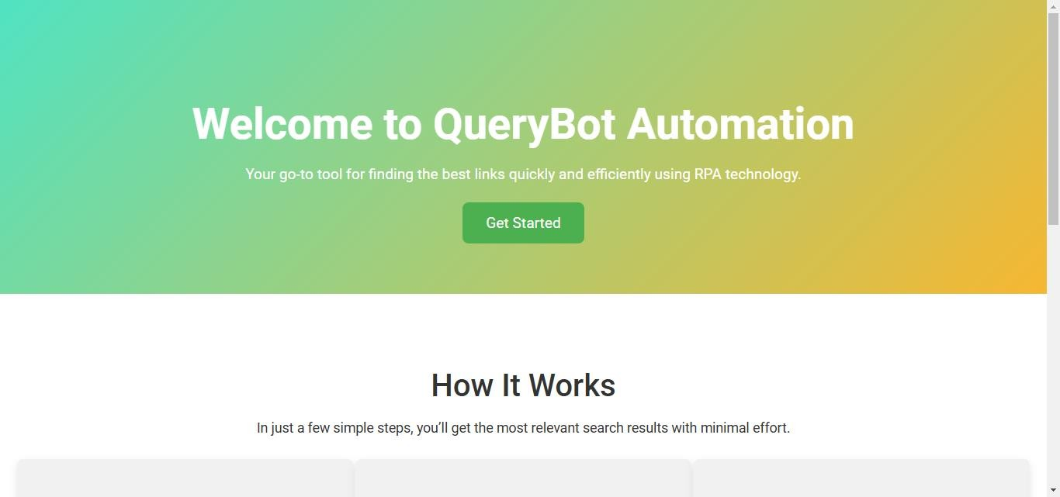

Fig.3.1 – Splash Screen

This Homepage displays the welcome page of the QueryBot Automation application. It features a visually appealing design with a clear call to action ("Get Started") and a brief overview of the application's core functionality - streamlining search results with minimal effort.

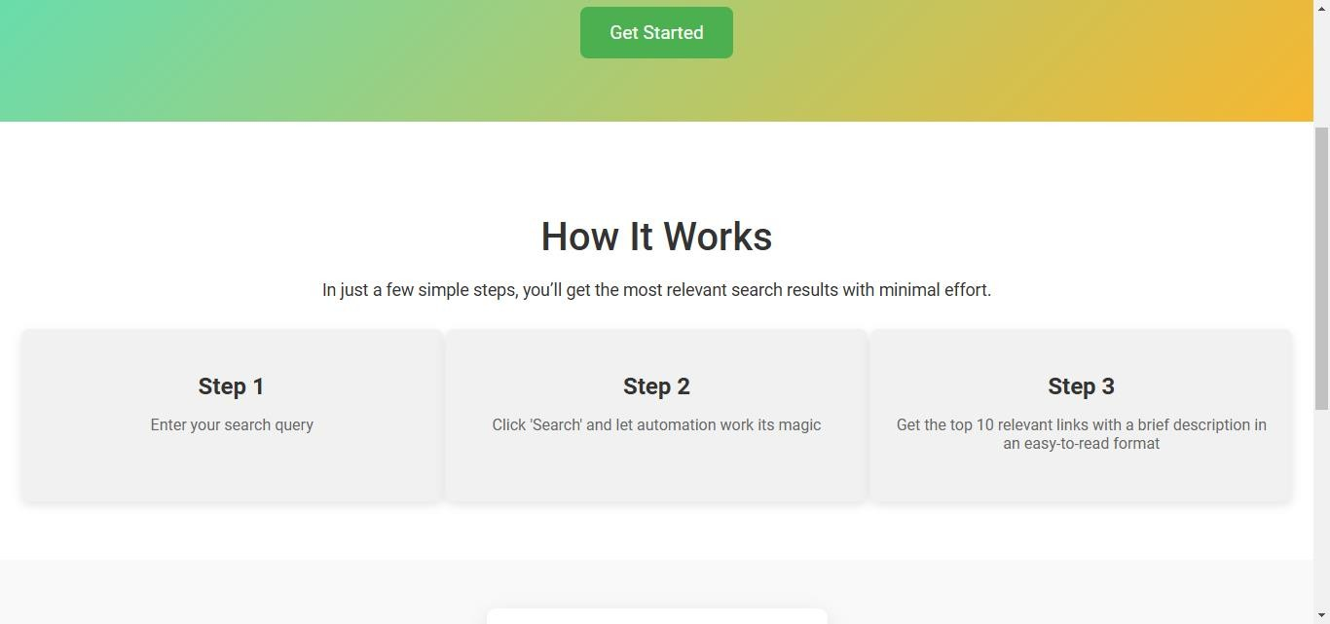

Fig.3.2: How it Works

The "How It Works" section of the QueryBot Automation application. It tells the users through the three simple steps involved in using the application.

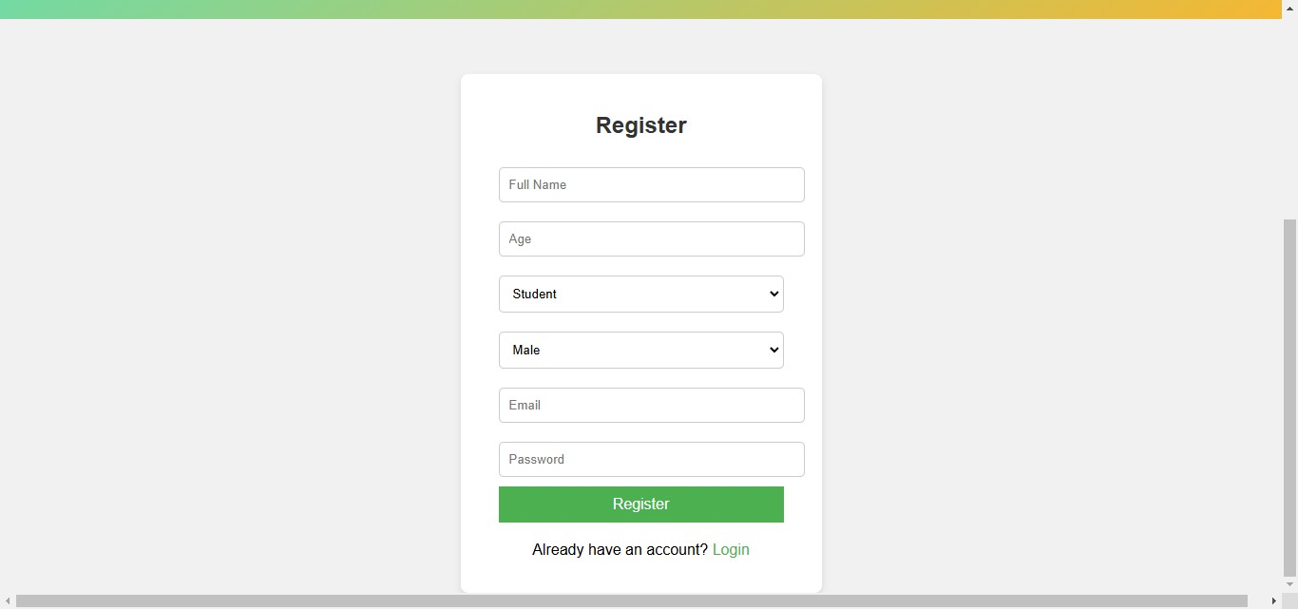

Fig.3.3: Registration

This screenshot shows the registration page of the QueryBot application. New users can easily create an account by filling out the required information, such as their name, age, and email address.

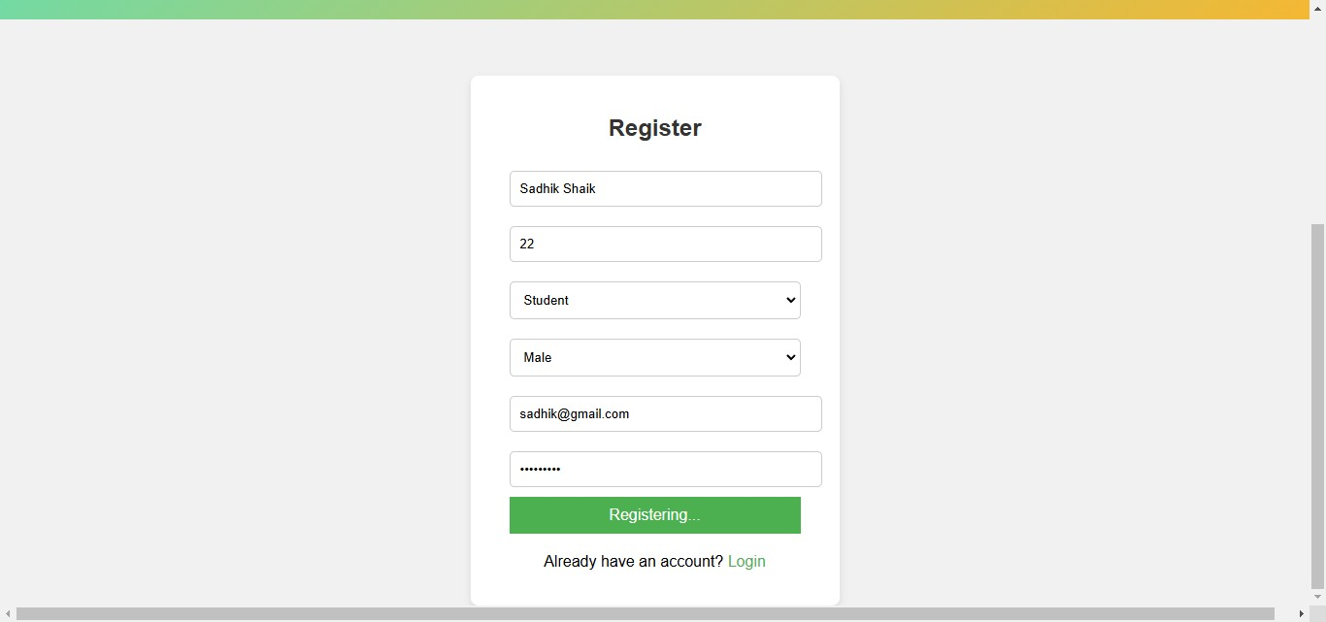

Fig.3.4: Registration Filling

This screenshot shows the registration page of the QueryBot application in action. A user has started the

registration process by filling in some of the required fields, such as their name, age, and email address. The page includes a clear call to action with a "Register" button and provides an option for existing users to log in.

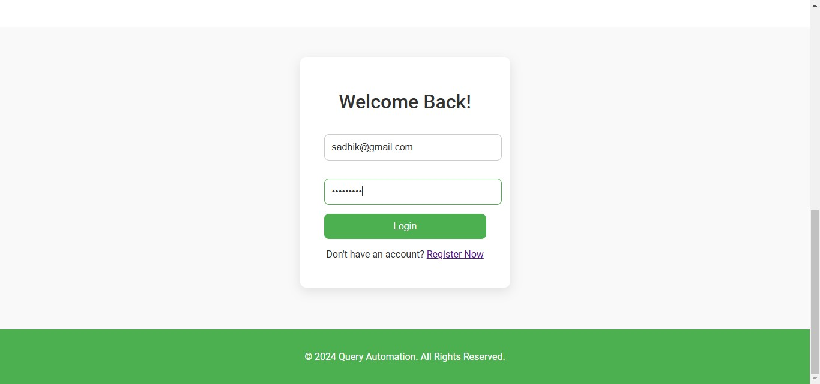

Fig.3.5: Login

This screenshot shows the login page of the QueryBot Automation application. Users can enter their registered email address and password to access the application's features. The page also provides an option for new users to register for an account.

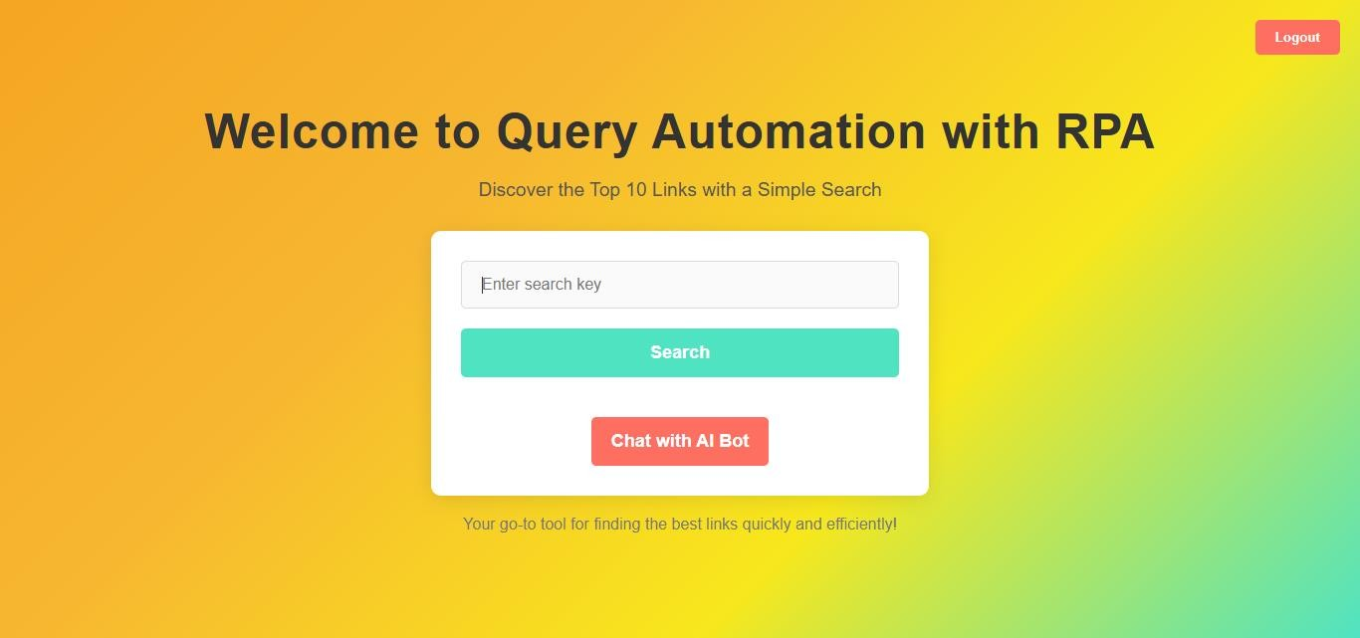

Fig.3.6: Home Page

This screenshot displays the main page of the QueryBot Automation application**.** The page has a clean and visually appealing design with a vibrant color scheme. The prominent headline "Welcome to QueryBot Automation" immediately conveys the purpose of the application.

**8.1 Key Features and Elements:**

* **"Discover the Top 10 Links with a Simple Search"** tagline clearly emphasizes the core functionality of QueryBot - to provide users with the top 10 most relevant links quickly and efficiently.
* **Search Bar:** A central input field is provided for users to enter their search queries. This is the primary interaction point for users to initiate the search process.
* **"Search" Button:** A prominent button prompts users to initiate the search. Once clicked, the application will use RPA techniques to automate the search process on the specified search engine and extract relevant information.
* **"Chat with AI Bot" Button:** This button indicates the integration of a chatbot feature. Users can interact with the chatbot to ask questions, refine their search queries, or get assistance with their information needs.
* **"Your go-to tool for finding the best links quickly and efficiently!"** tagline reinforces the application's value proposition and highlights its key benefits for users.

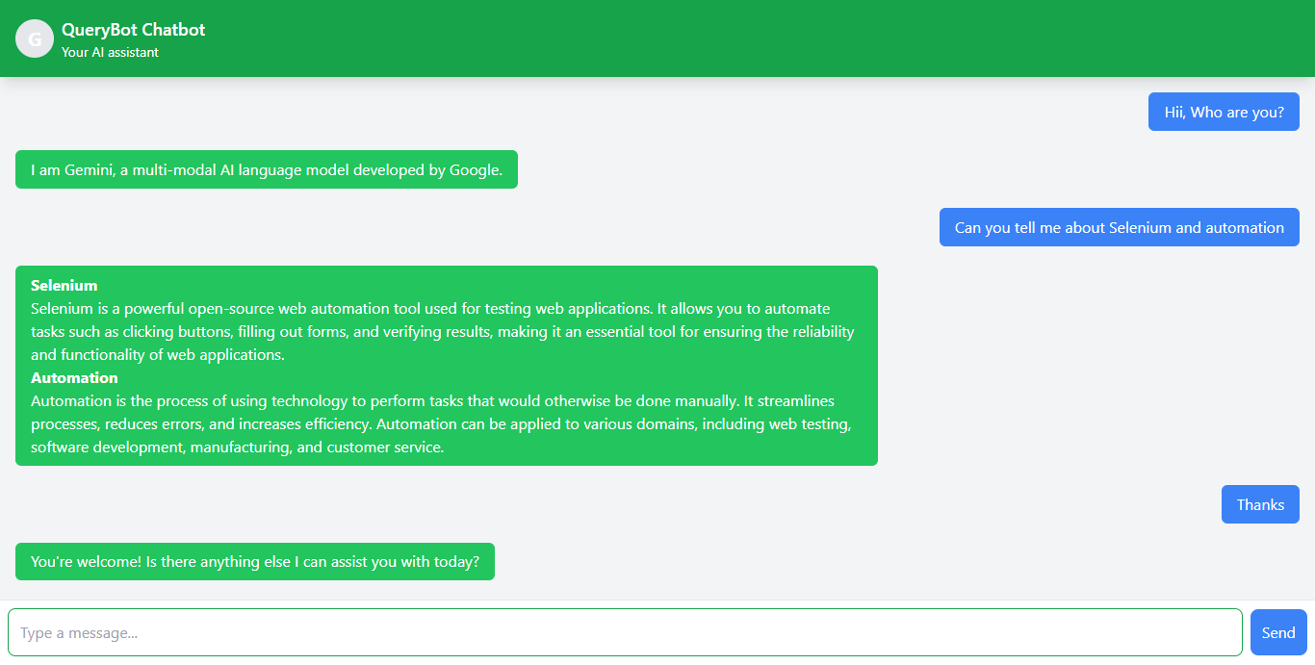

Fig.3.7: GEMINI AI Chatbot

This screenshot demonstrates the chatbot functionality integrated into QueryBot. The user has interacted with the chatbot by typing in the given input field. The chatbot responds with a brief introduction, identifying itself as Gemini, a multi-modal AI language model developed by Google.

Also, for example demonstration: the user has asked a question about "Selenium and automation." The chatbot provides a concise and informative response, explaining that Selenium is an open-source web automation tool used for testing web applications. It highlights Selenium's ability to automate tasks like

clicking buttons, filling out forms, and verifying results, emphasizing its importance in ensuring the reliability and functionality of web applications. The chatbot then goes on to define automation as the process of using technology to perform tasks that would otherwise be done manually, highlighting its benefits in terms of streamlining processes, reducing errors, and increasing efficiency.

This interaction demonstrates the chatbot's ability to understand and respond to user queries in a

clear and informative manner. It showcases the potential of integrating AI capabilities into QueryBot to enhance the user experience and provide valuable insights beyond basic search results.

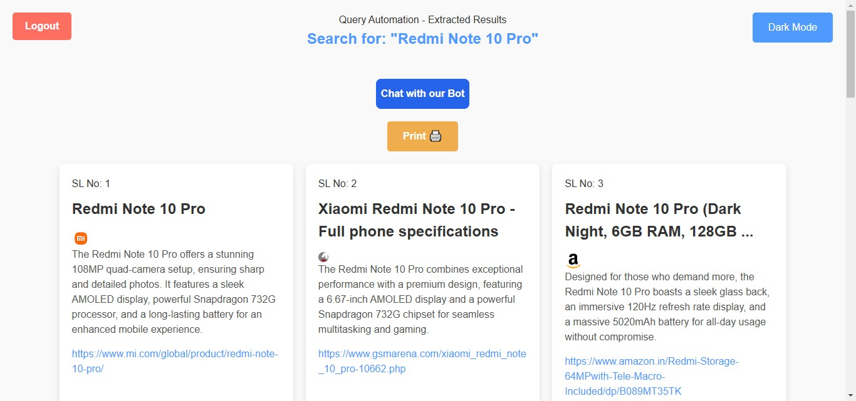

Fig.3.8: Output Screen

This displays the search results page of the QueryBot Automation application. The user has entered the search query "Redmi Note 10 Pro" and clicked the "Search" button.

Key features displayed in the screenshot:

* Organized Results: The search results are presented in a structured format, with each result displayed as a numbered list item (SL No. 1, SL No. 2, etc.).
* Concise Information: Each result includes the title of the webpage, a brief description of the content, and the URL of the webpage.
* Visual Appeal: The results are presented in a visually appealing and easy-to-read format, enhancing the user experience.
* "Chat with our Bot" Button: This button allows users to interact with the chatbot for further assistance or clarification regarding the search results.
* "Print" Button: This button enables users to easily print the search results for offline reference.

This screen demonstrates how QueryBot successfully automates the search process, extracts relevant information from the search engine results pages, and presents the results in a userfriendly and easily digestible format.

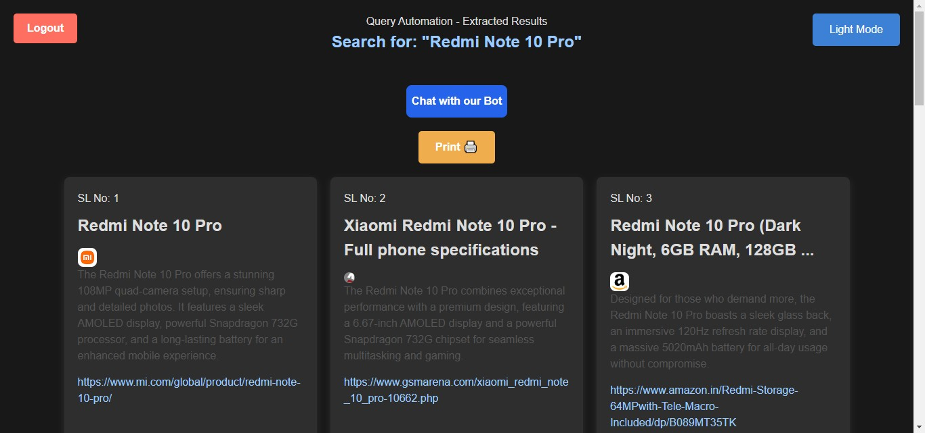

Fig.3.9: Output ScreeninDark Mode

This screen displays the search results page of the QueryBot Automation application in Dark Mode.

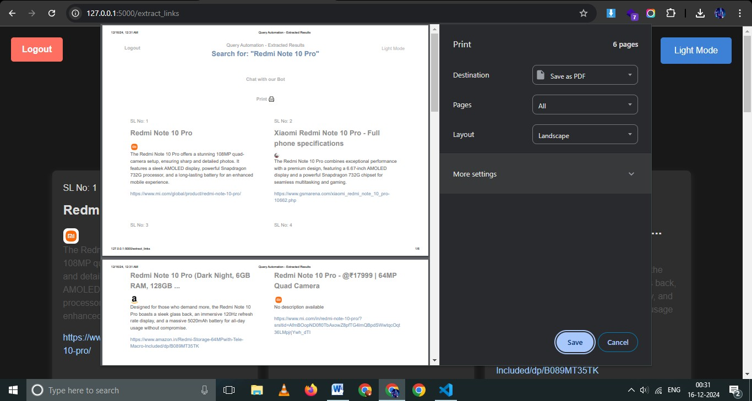

Fig.3.10: Saving Output as PDF

**This screen showcases the "Print" functionality of the QueryBot application.** The user has initiated the print process for the search results displayed on the screen.

**8.2 Key features and observations:**

* **Print Dialog:** The user is presented with a print dialog box, providing options to customize the printing process.

* **Destination:** The user can select the destination for the print output, such as a local printer or a PDF file.

* **Pages:** The user can choose to print all pages or select specific pages to print.

* **Layout:** The user can select the page layout, such as portrait or landscape.

* **Dark Mode Toggle:** The "Light Mode" button is visible, indicating the user has currently enabled Dark Mode.

## Backend Codebase

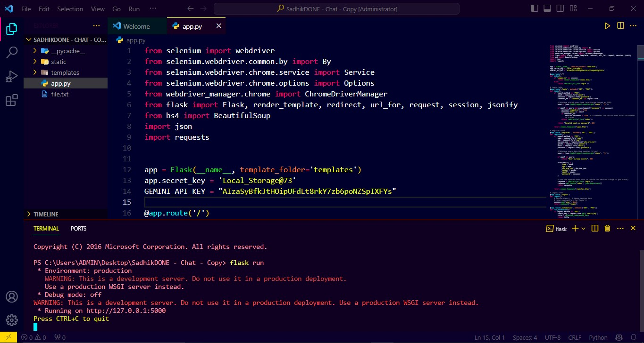

Fig.3.11: Flask as Server - Codebase

**CHAPTER-9**

# FUTURE ENHANCEMENTS AND COMMERCIALIZATION

QueryBot, with its current functionalities like AI-powered chat integration (Gemini model), search optimization for top 10 results, and user-friendly interface, already stands as a significant utility tool for automation in query management. However, technology is ever-evolving, and to keep QueryBot relevant, robust, and scalable, future enhancements and commercialization strategies must be explored. These developments will not only improve user experience but also unlock various monetization opportunities.

In this section, we will explore all the possible developments, enhancements, and strategies to commercialize QueryBot effectively, ensuring it caters to a broader user base and generates sustainable revenue.

**9.1 Future Enhancements**

**9.1.1 Multi-Language Support**

Currently, QueryBot supports user interaction in a single language. Introducing **multi-language support** can significantly improve its accessibility to a global audience. By using Natural Language Processing (NLP) models, QueryBot can automatically detect a user’s language and respond accordingly.

**Steps for Implementation**:

* + Integrate multilingual NLP libraries like Google Translate API or AWS Comprehend.
  + Expand Gemini AI configurations to generate responses in different languages.
  + Build a settings toggle where users can manually select their preferred language.

**Benefits**:

* + Reach diverse users across different countries.
  + Serve non-English-speaking users efficiently.
  + Improve user engagement and inclusivity.

**9.1.2 Voice Interaction Feature**

Adding a **voice-to-text** and **text-to-speech** feature will make QueryBot more userfriendly and accessible, especially for individuals who prefer speaking over typing.

**Steps for Implementation**:

* + Integrate Google Voice API or Web Speech API for real-time voice recognition.
  + Use TTS (Text-to-Speech) engines like Amazon Polly to convert QueryBot responses into audio.
  + Add a ―microphone‖ button for users to interact using their voice.

**Benefits**:

* + Improve accessibility for visually impaired users.
  + Enhance user convenience for hands-free operation.
  + Ideal for voice-first devices like smart assistants.

**9.1.3 Advanced AI Integration for Personalization**

While QueryBot provides general responses, future versions can include **personalized AI assistance**. By analyzing user behavior, preferences, and usage history, QueryBot can deliver tailored results.

**Steps for Implementation**:

* + Use AI models to analyze query patterns.
  + Store user preferences securely in local storage or cloud servers.
  + Offer suggestions or save recent searches for returning users.

**Benefits**:

* + Personalization improves user satisfaction and retention.
  + Faster query resolution with remembered preferences.
  + Creates a more interactive, human-like chatbot experience.

**9.1.4 Integration with Third-Party Tools and APIs**

To make QueryBot a robust tool for professionals and businesses, integrating it with **third-party tools and APIs** like CRM systems, productivity tools, and external databases will make it more versatile.

**Examples of Integrations**:

* + **CRM Integration**: Connect with tools like Salesforce or HubSpot to assist businesses with automated data fetching and customer query management.
  + **Google Workspace API**: Allow users to search emails, documents, and spreadsheets.
  + **Slack or Teams Integration**: Bring QueryBot into workplace communication tools for real-time query automation.

**Benefits**:

* + Makes QueryBot a powerful tool for businesses.
  + Enhances workplace productivity and saves time.
  + Opens opportunities for B2B (Business-to-Business) partnerships.

**9.1.5 Mobile Application Development**

Currently, QueryBot runs as a web-based application. Developing **mobile applications** for both Android and iOS will significantly enhance accessibility and usage.

**Steps for Implementation**:

* + Use frameworks like Flutter or React Native to build a cross-platform mobile version.
  + Ensure the app supports both online and offline modes (using cache storage).
  + Add push notifications for reminders and updates.

**Benefits**:

* + Provides users with on-the-go access.
  + Expands the user base, as mobile usage is significantly higher than desktop.
  + Adds opportunities for in-app purchases and advertisements.

**9.1.6 Data Analytics Dashboard**

Adding a **data analytics dashboard** will allow businesses or administrators to monitor QueryBot usage, query trends, and user engagement metrics.

**Steps for Implementation**:

* + Integrate data visualization libraries like Chart.js or D3.js.
  + Display real-time statistics like frequently searched topics, user engagement rates, and chat performance.
  + Ensure a clean and simple user interface for the analytics dashboard.

**Benefits**:

* + Businesses can analyze which queries are most common.
  + Helps improve QueryBot responses by identifying gaps.
  + Adds value for enterprise-level users.

**9.1.7 Offline Query Support**

To ensure that users with limited internet access can use QueryBot, future enhancements can include **offline query support**. Cached data and results can be stored for previously searched queries.

**Steps for Implementation**:

* + Use service workers to cache recent query results.
  + Build a lightweight offline mode to display stored search results.
  + Sync data when the user reconnects to the internet.

**Benefits**:

* + Enables usage in areas with poor or no internet connectivity.
  + Improves reliability and usability.
  + Appeals to users in rural or remote regions.

**9.1.8 Security and Privacy Enhancements**

User security and privacy are of utmost importance. Future updates can include:

* + End-to-end encryption for all chat communications.
  + Multi-factor authentication (MFA) for login security.
  + GDPR and HIPAA compliance for data privacy.

**Benefits**:

* + Builds user trust and confidence.
  + Ensures compliance with global privacy standards.
  + Protects sensitive user data.

**9.1.9 Gamification Features**

To make QueryBot more engaging, **gamification elements** can be added, such as reward points, leaderboards, and badges for regular users.

**Examples**:

* + Users earn points for every successful query.
  + Create challenges for users to explore new features.
  + Display leaderboards for top active users.

**Benefits**:

* + Increases user engagement and loyalty.
  + Makes the interaction more fun and competitive.
  + Encourages users to explore all functionalities.

**9.1.10 AI-Powered Recommendations**

Using AI to provide **smart recommendations** will enhance user experience. For example:

* + Suggesting related search queries.
  + Providing follow-up questions to clarify user intent.
  + Offering links or solutions based on previous searches.

**Benefits**:

* + Speeds up query resolution.
  + Improves user satisfaction through accurate suggestions.
  + Makes QueryBot a more proactive assistant.

**Commercialization Strategies**

**9.1.11 Subscription-Based Model**

Implementing a **subscription-based model** where users pay a monthly or yearly fee to access advanced features like personalized assistance, analytics dashboard, and priority responses.

**Types of Plans**:

* + **Free Plan**: Limited features (basic search and chatbot).
  + **Premium Plan**: Includes advanced AI features, voice integration, and third-party tool integration.
  + **Enterprise Plan**: Customizable for businesses with analytics and API support.

**9.1.12 Freemium Model with Ads**

A **freemium model** can attract users with free access while monetizing through advertisements. Users can pay to remove ads and unlock premium features.

**9.1.13 B2B Licensing**

Offer QueryBot as a **licensed tool** for businesses, organizations, and enterprises to automate query handling, search optimization, and customer support.

**9.1.14 API Monetization**

Provide QueryBot as an **API service** where developers can integrate its functionalities into their own applications for a fee.

**9.1.15 White-Label Solutions**

Sell QueryBot as a **white-label solution** to companies, allowing them to rebrand and customize it for their needs.

**9.1.16 In-App Purchases**

Add **in-app purchases** for advanced tools, extra storage, or premium search features.

**9.1.17 Partnership Programs**

Collaborate with organizations, educational institutes, or healthcare providers to offer specialized QueryBot versions tailored for their needs.

By implementing these future enhancements and commercialization possibilities, QueryBot can evolve into a comprehensive, scalable, and user-centric solution. From multilanguage support to AI-powered personalization, the proposed developments will ensure QueryBot remains innovative and competitive. Additionally, the outlined monetization models will create revenue streams, ensuring its long-term sustainability and market success.

# CHAPTER-10

# RESULTS AND DISCUSSIONS

**10.1 Overcoming Limited User Base and Expandable Architecture**

A major drawback in many query management tools is their inability to cater to a broader user base due to rigid and non-scalable architectures. QueryBot effectively overcomes this limitation through its **expandable architecture**. By leveraging advanced AI models (like Gemini) and enabling integration with third-party tools (e.g., CRMs, analytics, and voice recognition services), QueryBot ensures scalability without compromising on performance.

The system is designed to adapt to evolving user needs and growing demands, making it suitable for small businesses, large enterprises, and individual users alike. QueryBot’s cloud-based infrastructure also allows seamless scaling to accommodate a larger user base as adoption increases.

**Key Advantage**:

* + Expandability ensures QueryBot can integrate into various industries, including education, e-commerce, healthcare, and enterprise-level operations.
  + Scalable architecture prevents performance bottlenecks during periods of high usage.

**10.2 Crossing Communication Barriers and Data Privacy Issues**

One of the most common barriers in query-based systems is ineffective communication due to language limitations or privacy concerns. QueryBot addresses this challenge through **multi-language support** (future enhancement) and stringent **data privacy protocols**.

The system can be enhanced to automatically detect and respond in multiple languages, thus making it user-friendly for non-native speakers and global audiences. Additionally, by implementing **end-to-end encryption** and adhering to global compliance standards like GDPR, QueryBot ensures that all user interactions remain secure and confidential.

**Key Features**:

* + In-app chat with robust encryption guarantees secure communication.
  + Language barriers are eliminated through multi-language AI models, making QueryBot accessible globally.

**10.3 Enhancing Query Management Efficiency**

Existing query management systems often struggle with inefficiencies like **inaccurate responses**, **slow query resolution**, and a lack of context-aware replies. QueryBot resolves these issues through the integration of **AI-powered recommendations** and **personalized assistance**.

* + Using machine learning algorithms, QueryBot learns from user interactions to deliver faster and more accurate responses.
  + Smart recommendations suggest related queries or follow-up questions, ensuring better user satisfaction.
  + Context-aware responses allow QueryBot to understand user intent and tailor replies accordingly.

These improvements significantly enhance query resolution times while maintaining accuracy, making it a superior solution to traditional query-handling systems.

**Key Benefits**:

* + Faster query resolution improves user productivity.
  + AI personalization ensures user-friendly and accurate interactions.

**10.4 Overcoming Implementation Costs**

Cost constraints have been a critical drawback in traditional query management systems, especially for small businesses and startups. QueryBot’s **SaaS (Software as a Service) model** addresses this issue effectively. By offering a subscription-based service, businesses can access the platform without heavy upfront infrastructure or development costs.

The SaaS-based architecture reduces the need for expensive on-premise equipment and allows users to **scale** their usage based on their needs. For enterprise-level users, QueryBot offers customization options that align with their existing systems, further reducing implementation barriers.

**Key Advantage**:

* + Cost-effective SaaS deployment makes QueryBot affordable for businesses of all sizes.
  + Pay-as-you-go pricing models ensure flexibility and scalability.

**10.5 Addressing Limitations in Existing Tools**

Existing query-handling tools often fail to provide a comprehensive solution due to issues like:

* + Inability to handle **voice inputs** for hands-free usage.
  + Lack of support for **third-party tool integration** (e.g., CRM, productivity apps).
  + Limited **offline functionality** and dependency on internet connectivity.

QueryBot overcomes these drawbacks seamlessly:

* + **Voice integration** enables hands-free query resolution, ideal for busy professionals and differently-abled users.
  + **Third-party integrations** with tools like Slack, Salesforce, and Google Workspace make QueryBot a valuable asset for businesses.
  + **Offline support** allows users to access stored query results even without an active internet connection.

By addressing these limitations, QueryBot creates a robust and user-friendly platform that caters to modern requirements.

**Key Features**:

* + Voice interaction ensures accessibility for all user types.
  + Offline support enhances reliability in low-connectivity regions.

QueryBot not only resolves existing drawbacks but also introduces innovative features that enhance user experience, productivity, and accessibility. Its superior design and functionality make it a valuable tool for a wide range of applications.

# CHAPTER-11

# CONCLUSION

QueryBot offers a robust and innovative solution to modern query-handling challenges by addressing critical inefficiencies in traditional systems. With its AI-powered responses, seamless integration capabilities, and user-friendly design, QueryBot significantly improves query resolution, enhances user satisfaction, and increases productivity for individuals and businesses alike.

The system’s scalable, expandable architecture ensures it can adapt to growing demands, while features like voice interaction, offline accessibility, and multi-language support make it versatile and inclusive. QueryBot not only simplifies query management but also sets a new benchmark for efficiency, accessibility, and security through advanced data privacy measures.

As the world increasingly shifts toward digital communication tools, QueryBot emerges as a future-ready platform capable of serving diverse industries. It highlights the importance of intelligent design, real-time responsiveness, and cost-effective implementation. By bridging gaps in communication and query resolution, QueryBot stands as a scalable, reliable, and forward-thinking solution that paves the way for smarter, more effective digital experiences.

# REFERENCES

1. Jansen, Jim & Spink, Amanda. (2009). Investigating customer click through behaviour with integrated sponsored and non-sponsored results. International Journal of Internet Marketing and Advertising, 5(1/2), 74-94. International Journal of Internet Marketing and Advertising. 5. 10.1504/IJIMA.2009.021951.
2. Bansal, Deepak. (2024). How Search Engine Optimization (SEO) Grew from Nascent Stages to AI. International Journal For Multidisciplinary Research. 6. January-February 2024. 10.36948/ijfmr.2024.v06i01.14151.
3. J. G. Enríquez, A. Jiménez-Ramírez, F. J. Domínguez-Mayo and J. A. García-García, "Robotic Process Automation: A Scientific and Industrial Systematic Mapping

Study," in IEEE Access, vol. 8, pp. 39113-39129, 2020, doi: 10.1109/ACCESS.2020.2974934.

1. Gupta, Ankur & Prabhat, Purnendu & Sawhney, Sahil & Gupta, Rajesh & Tanwar, Sudeep & Kumar, Neeraj & Shabaz, Dr. Mohammad. (2022). Robotic Process Automation use cases in academia and early implementation experiences. IET Software. 17. n/a-n/a. 10.1049/sfw2.12061.
2. a P, Jyothi & Shankar, Anirudh & JR, Ashwath & Maniyar, Humayun & Sr, Nagavi & Ambarkhane, Shreeganesh. (2024). Robotic Process Automation: In-Depth Analysis of Advanced Automation Techniques and Technologies. 1-6. 10.1109/InC460750.2024.10649336.
3. Plattfaut, Ralf & Borghoff, Vincent. (2022). Robotic Process Automation – A Literature-Based Research Agenda. Journal of Information Systems. 36.

10.2308/ISYS-2020-033.

1. A. Mishra, S. Mishra and N. S. Kumar, "Data Analysis using Robot Process Automation Study on Web Scraping using UI Path Studio," 2022 4th International Conference on Advances in Computing, Communication Control and Networking

(ICAC3N), Greater Noida, India, 2022, pp. 2221-2225, doi:

10.1109/ICAC3N56670.2022.10074502.

1. Position Papers of the 2018 Federated Conference on Computer Science and Information Systems, M. Ganzha, L. Maciaszek, M. Paprzycki (eds). ACSIS, Vol. 16, pages 9–16 (2018)
2. Müller, J., & Prange, C. (2017). Robotic Process Automation (RPA): A Systematic Literature Review. International Journal of Information Management, 37(4), 385401.
3. Singh, R., & Kaur, A. (2022). Robotic Process Automation: A Review. International Journal of Engineering Research and Technology (IJERT), 11(5), 151-156.
4. Huh, E., & Lee, J. (2018). A Study on the Integration of RPA and Selenium for Test Automation. Journal of Information Systems and Technology, 6(2), 1-10.
5. Kumar, A., & Singh, R. (2022). Enhancing Test Automation with RPA and Selenium: A Case Study. International Journal of Computer Science and Information Technology, 12(1), 123-130.
6. Zhang, Y., & Li, H. (2021). A Survey of Test Automation Frameworks Based on Selenium and RPA. Journal of Software, 16(1), 1-15.
7. Goyal, A., & Sharma, R. (2023). A Comparative Study of Selenium and RPA for Test Automation. Journal of Emerging Technologies and Innovative Research (JETIR), 10(1), 1-8.

# APPENDIX-A

# PSEUDOCODE FOR QUERYBOT

## 13 Imports and Initialization

**13.1 Import Required Libraries and Frameworks**

* + 1. Import Flask for web application backend.
    2. Import Selenium for browser automation and web scraping.

13.1.3 Import Beautiful Soup for parsing HTML content.

13.1.4 Import requests for API calls.

13.1.5 Import json for handling data serialization.

* + 1. Import TailwindCSS for frontend styling in templates.

**13.2 Initialize Flask Application**

13.2.1Create an instance of the Flask app.

13.2.2Configure the secret key for session management.

**13.3 User Authentication System**

**13.4 User Login**

13.4.1 Display login form to the user.

* + 1. Accept email and password as input fields.
    2. Validate user credentials.
    3. Parse stored user data from cookies.

13.4.5 Compare input credentials with stored data.

* + 1. Manage session on successful login.
    2. Set a session flag to track user state.

**13.5 User Registration**

13.5.1 Display registration form to the user.

13.5.2 Accept details such as name, age, gender, email, and password.

* + 1. Check for duplicate accounts.
    2. Verify if the email already exists in stored user data.
    3. Store user details in JSON format within cookies.

**13.6 Logout Functionality**

13.6.1 Clear session 4details upon logout.

* + 1. Redirect user to the login page.

* 1. **Core Search Automation**

**13.7 Search Query Input**

13.7.1 Provide an input field for entering a search query.

* + 1. Submit the query to initiate automation.

**13.8 Web Scraping via Selenium**

13.8.1 Configure Selenium Chrome WebDriver.

* + 1. Set up the Chrome browser environment.
    2. Optionally enable headless mode for non-GUI scraping.
    3. Perform Google search automation.
    4. Load Google search page.
    5. Input the search query into the search bar.
    6. Submit the query to retrieve results.
  1. **Extract Links and Metadata**

13.9.1 Parse search results using BeautifulSoup.

13.9.2 Locate link containers on the result page.

13.9.3 Extract URLs, titles, metadata, and optional image URLs.

* + 1. Iterate through multiple result pages for comprehensive data.

**Display Results to Users**

* 1. **Generate HTML Output**

13.10.1 Render results in a card-based layout.

* + 1. Include titles, descriptions, and clickable links in each card.
    2. Display images if available.
    3. Integrate a print button for exporting results.

13.10.5 Allow toggling between light and dark modes using localStorage.

**AI Chatbot Integration**

* 1. **Initialize Gemini Chatbot**

13.11.1 Import and configure the Google Generative AI Gemini API.

* + 1. Set up API credentials and model configuration.
    2. Create a chat session for user interaction.
    3. Allow users to input messages in a text field.
    4. Send user queries to the chatbot for processing.
  1. **Process AI Responses**
     1. Capture and display bot responses dynamically.
     2. Convert response text to HTML using showdown.
     3. Append messages to the chat container with appropriate styling.

**Session and Cookie Management**

* 1. **Session Handling**
     1. Track user login state with session flags.
     2. Enable persistent sessions for ―Remember Me‖ functionality.
  2. **Cookie Storage**
     1. Store user data in cookies as serialized JSON.
     2. Retrieve and deserialize cookies for validation and updates.

**Frontend Components**

* 1. **User Interface Design**
     1. Create responsive templates using TailwindCSS.
     2. Design distinct pages for login, registration, search, and chat.
     3. Implement accessibility features, including dark mode and keyboard navigation.

**Additional Features and Enhancements**

* 1. **Future Enhancements**
     1. Expand search capabilities to support multiple search engines.
     2. Enhance chatbot responses with domain-specific knowledge bases.
     3. Integrate analytics for tracking user activity and search trends.
     4. Optimize scraping to respect robots.txt guidelines and minimize server load.

**APPENDIX-B**

**SCREEN SHOTS**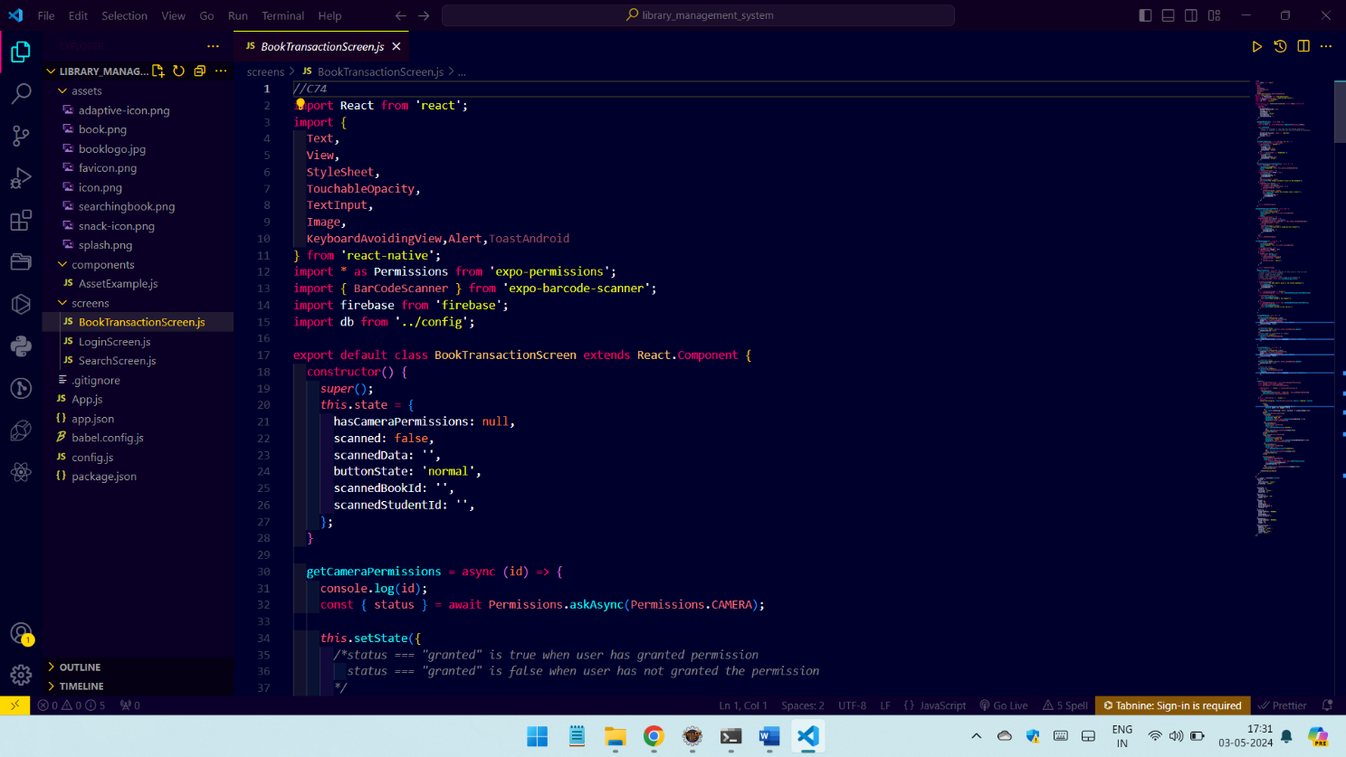

Fig.4.1: Flask code as Backend

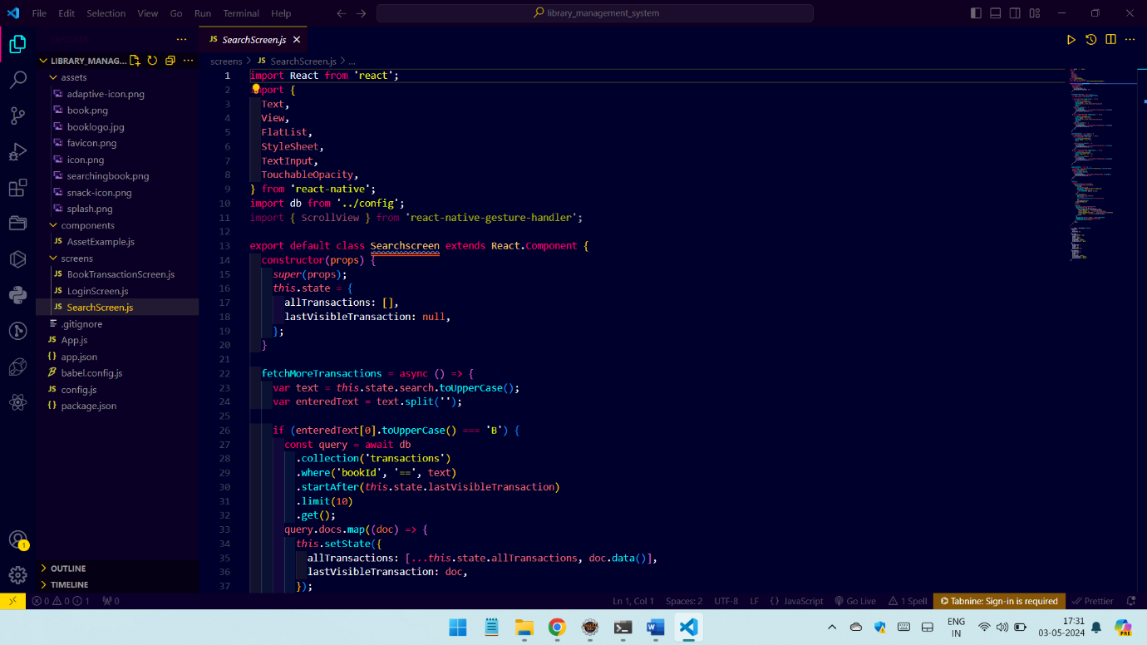

Fig.4.2: Login Page - Codebase

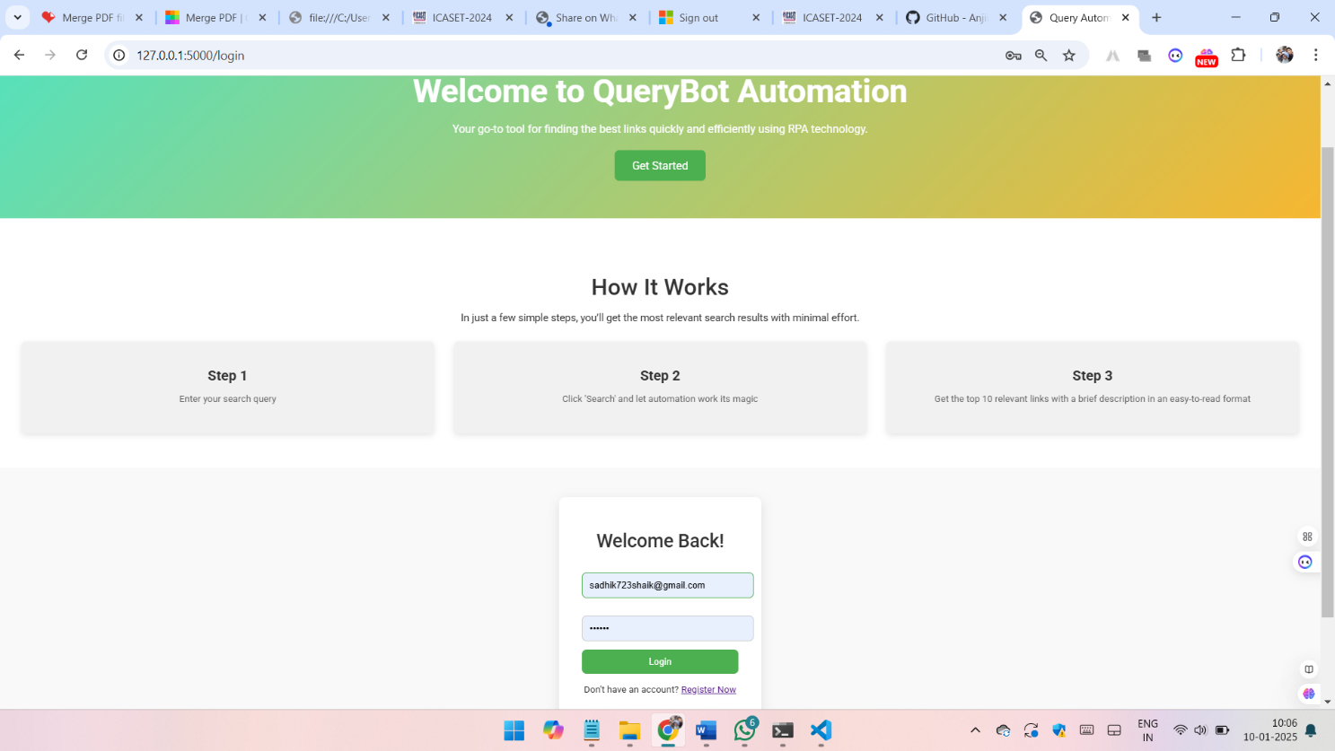

Fig.4.3: Flask WebPage

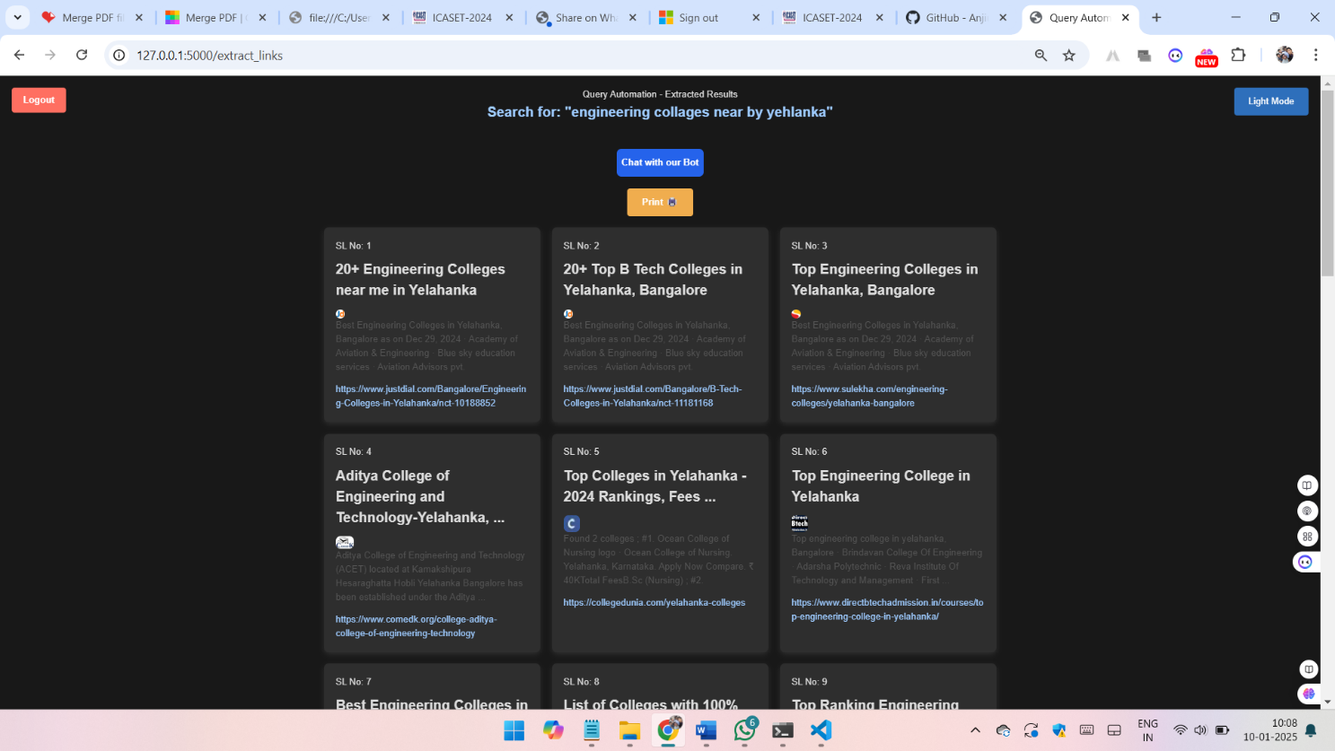

Fig.4.3 Result of the output

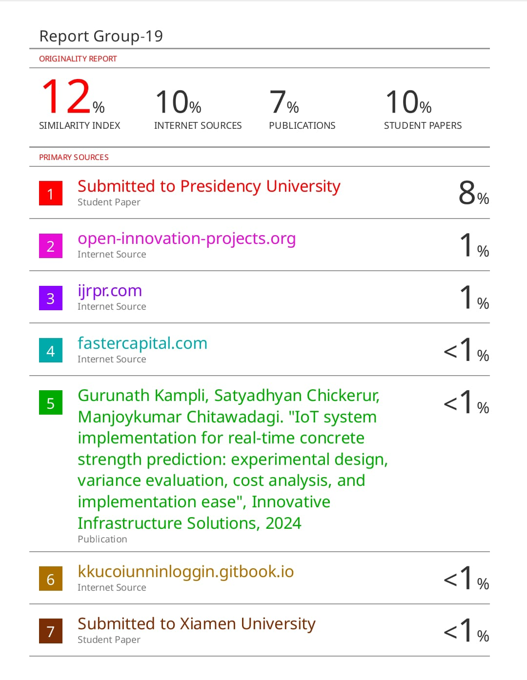

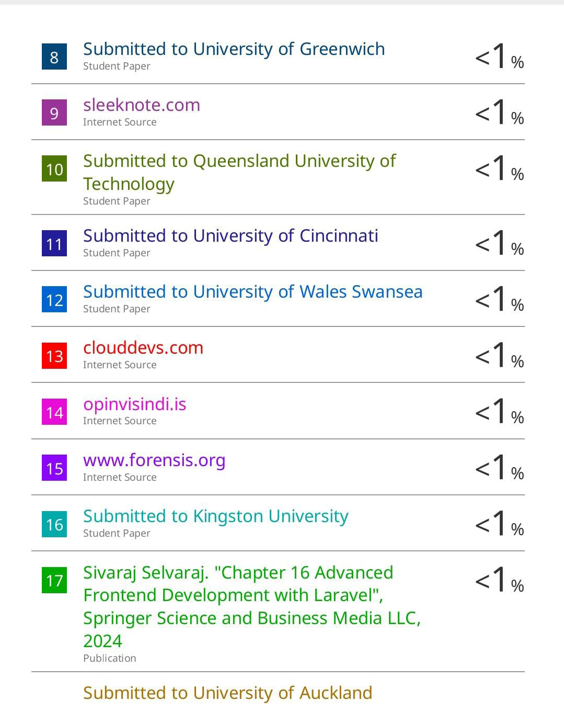

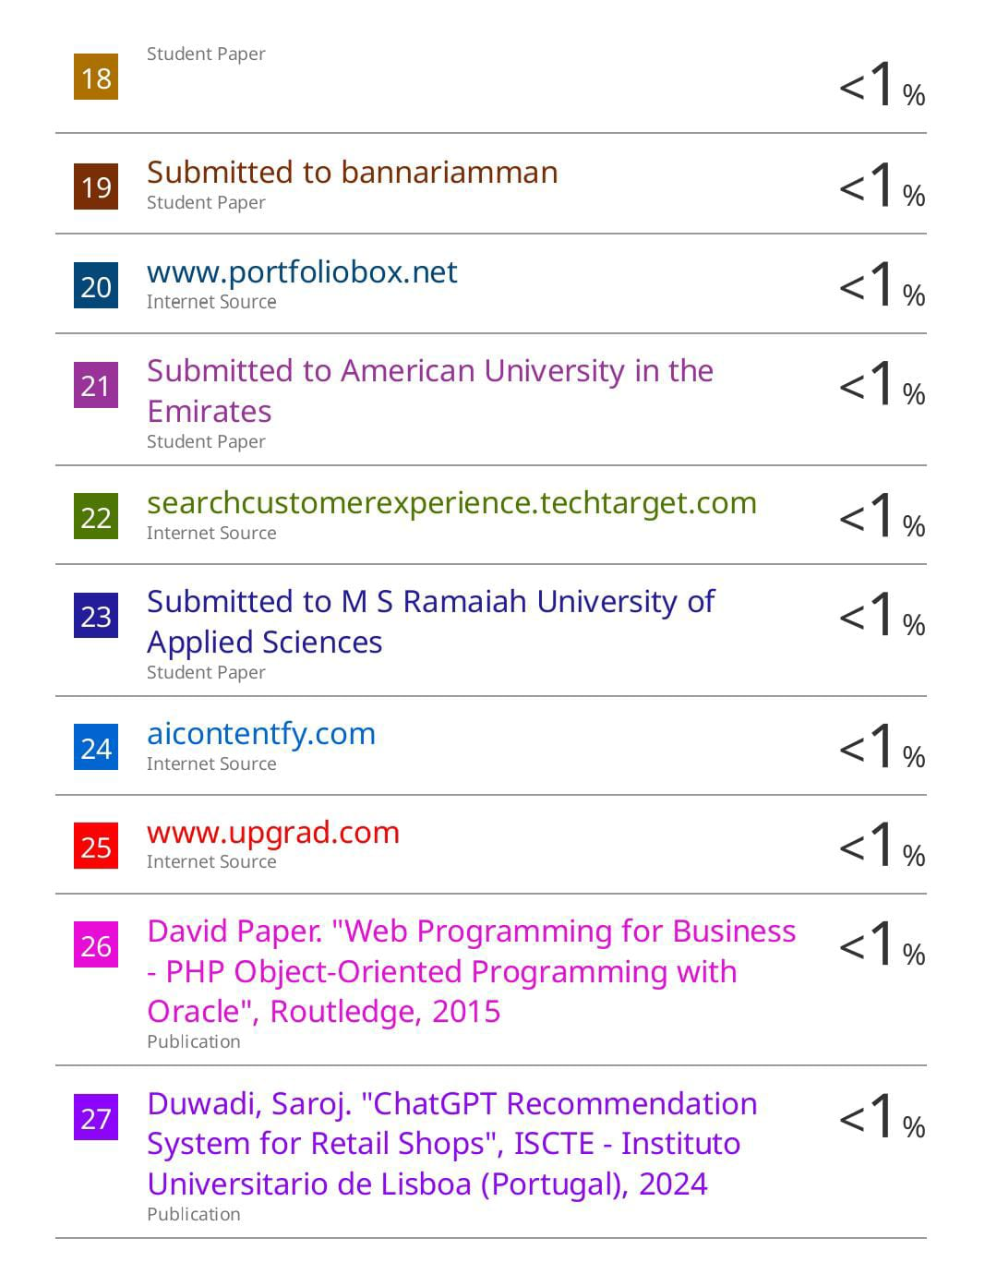

**`**

**APPENDIC-C**

**ENCLOSURES**

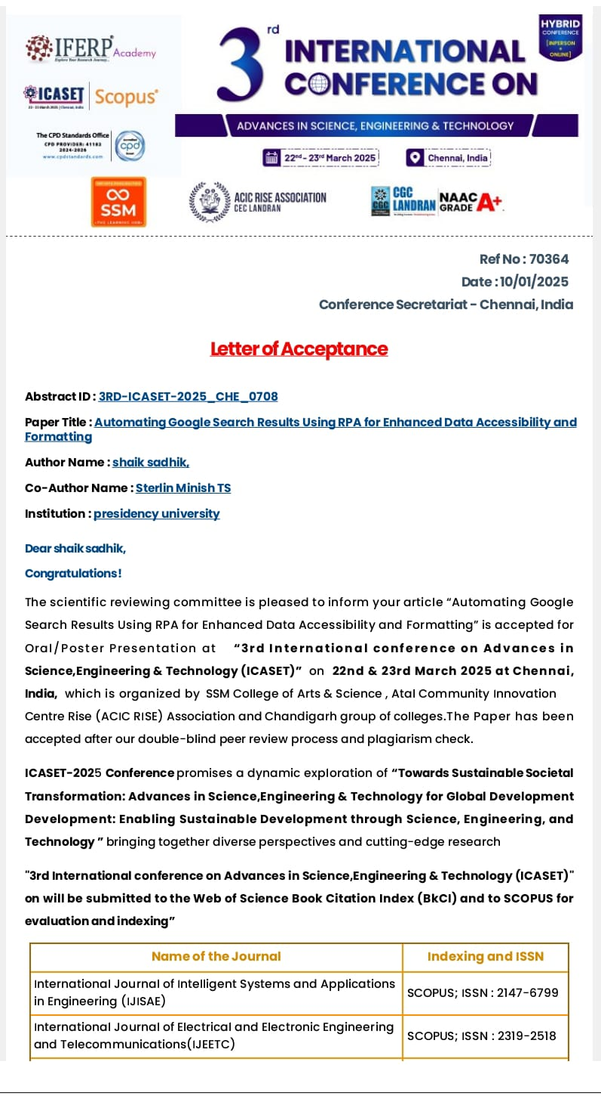

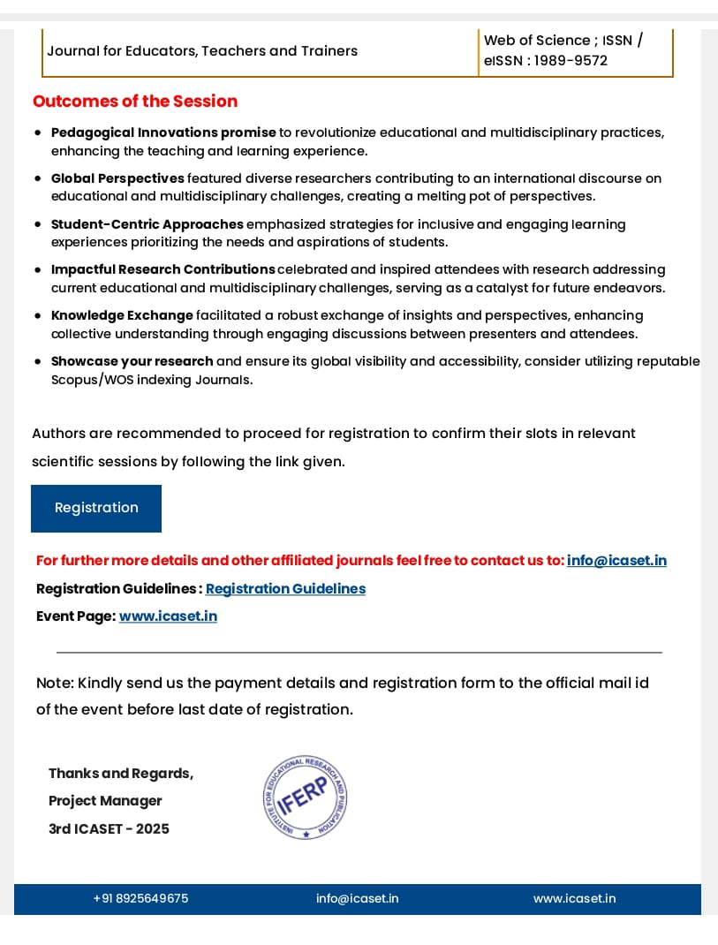**+**



Based on the abstract provided for your project **QueryBot**, the most relevant **United Nations Sustainable Development Goals (SDGs)** are:

**1. SDG-9: Industry, Innovation, and Infrastructure**

* **Reason**: Your project focuses on innovation by leveraging **Robotic Process Automation (RPA)** to streamline search processes and organize unstructured data. It directly aligns with building resilient infrastructure, fostering innovation, and promoting sustainable industrialization.

**2. SDG-4: Quality Education (Optional, if relevant)**

* **Reason**: If QueryBot is used in educational settings or to facilitate access to structured information for learning, it supports SDG-4 by enhancing accessibility to knowledge resources.

**3. SDG-12: Responsible Consumption and Production (Optional, if applicable)**

* **Reason**: By reducing manual effort and optimizing search processes, your project promotes efficient use of resources, reducing digital overconsumption or redundancy.

Would you like help mapping your project's objectives to these goals for a formal document or presentation?